**实验四： RDD 编程实践**

**实验基本信息：**

时间： : 2024年9月23日

实验类型： □验证性 □设计性 ☑综合性

班级： 计算机科学与技术专业（中外合作）4班 班级代码:

理论老师： 邱开金 实验指导： 邱开金

**实验报告提交说明：**

本次实验需要撰写实验报告，实验报告填写时以完成实验任务为目的，先简要回答完成实验任务需要的步骤或需要执行的命令代码，再配以结果截图予以说明，图片数量不宜过多，能说明问题即可。最后配上总结，并提交到教师指定位置。

**实验目的：**

1. 熟练掌握 RDD 常用操作，如的 filter,map 等命令解决实际问题。

2. 熟练利用键值对 RDD 解决实际问题。

**实验任务：**

1. 依次运行下列RDD操作：

启动配置：

cd /usr/local/hadoop

./sbin/start-dfs.sh

cd /usr/local/spark

./bin/pyspark

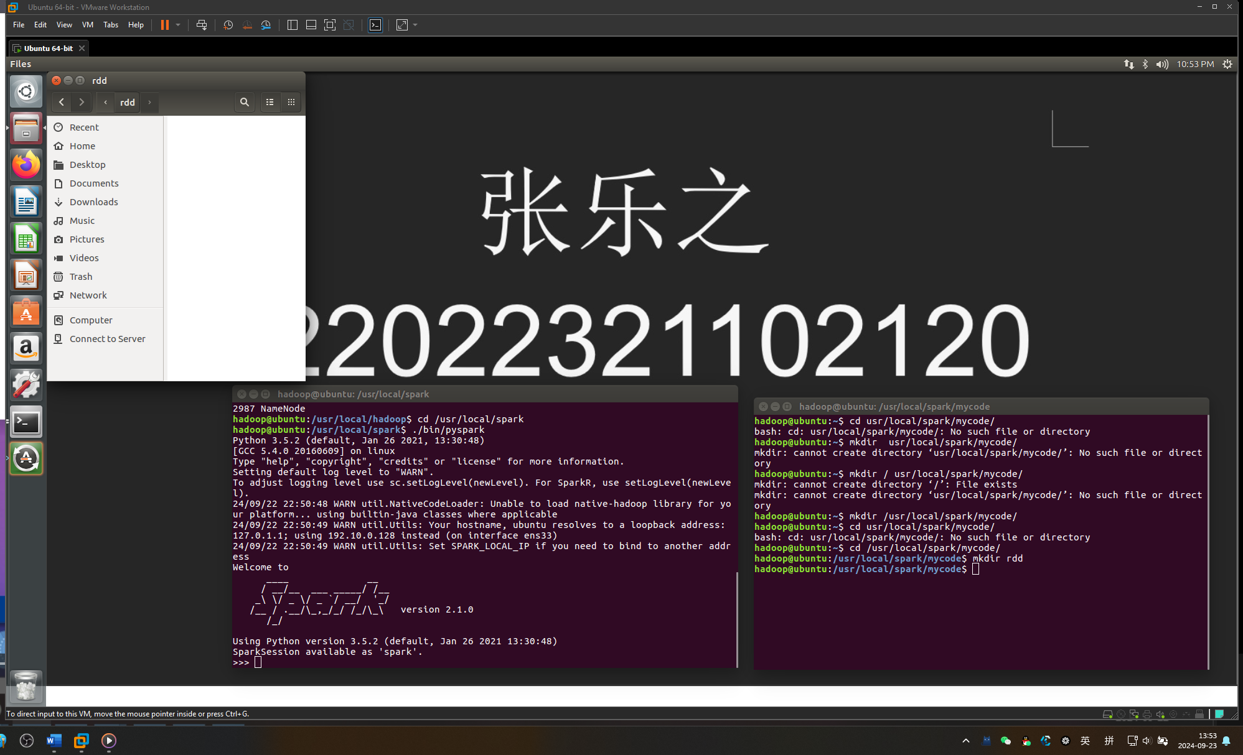

加载数据集：

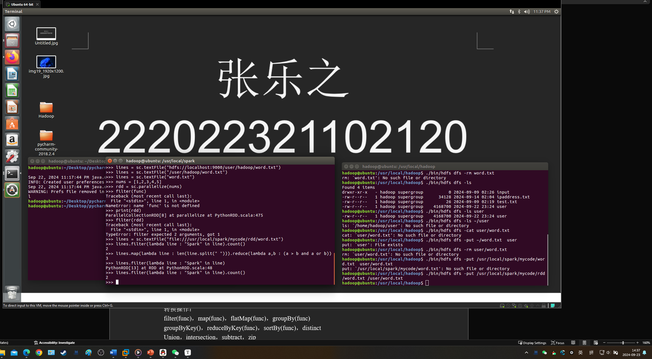

实验4第一题：

1、foreach

from pyspark import SparkConf, SparkContext

if __name__ == '__main__':

conf = SparkConf().setMaster("local[*]").setAppName("My App")

sc = SparkContext(conf = conf)

lines = sc.textFile("file:///usr/local/spark/mycode/rdd/word.txt")

lines.foreach(print)

sc.stop()

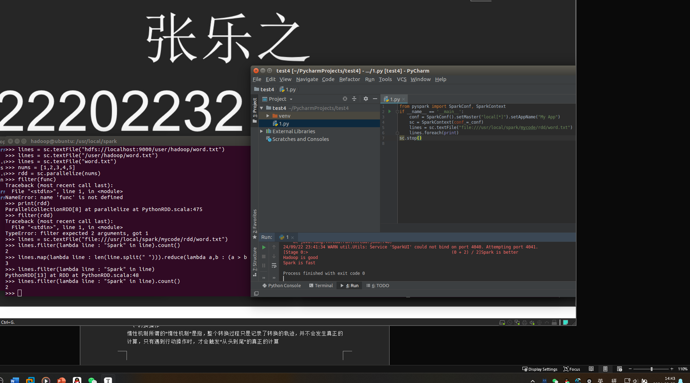

>>> array = [1,2,3,4,5]

>>> rdd = sc.parallelize(array)

>>> rdd.foreach(print)

1

2

3

4

5

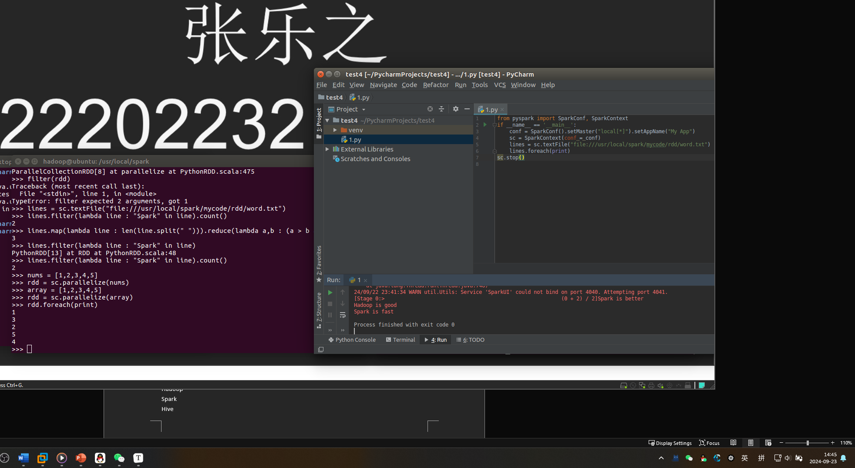

键值（K，V）：

>>> list = [("Hadoop",1),("Spark",1),("Hive",1),("Spark",1)]

>>> pairRDD = sc.parallelize(list)

>>> pairRDD.keys().foreach(print)

Hadoop

Spark

Hive

Spark

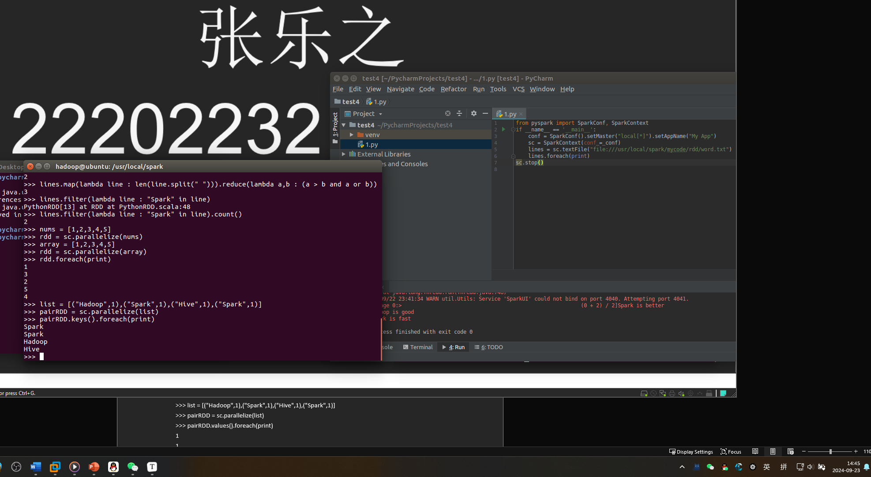

>>> list = [("Hadoop",1),("Spark",1),("Hive",1),("Spark",1)]

>>> pairRDD = sc.parallelize(list)

>>> pairRDD.values().foreach(print)

1

1

1

1

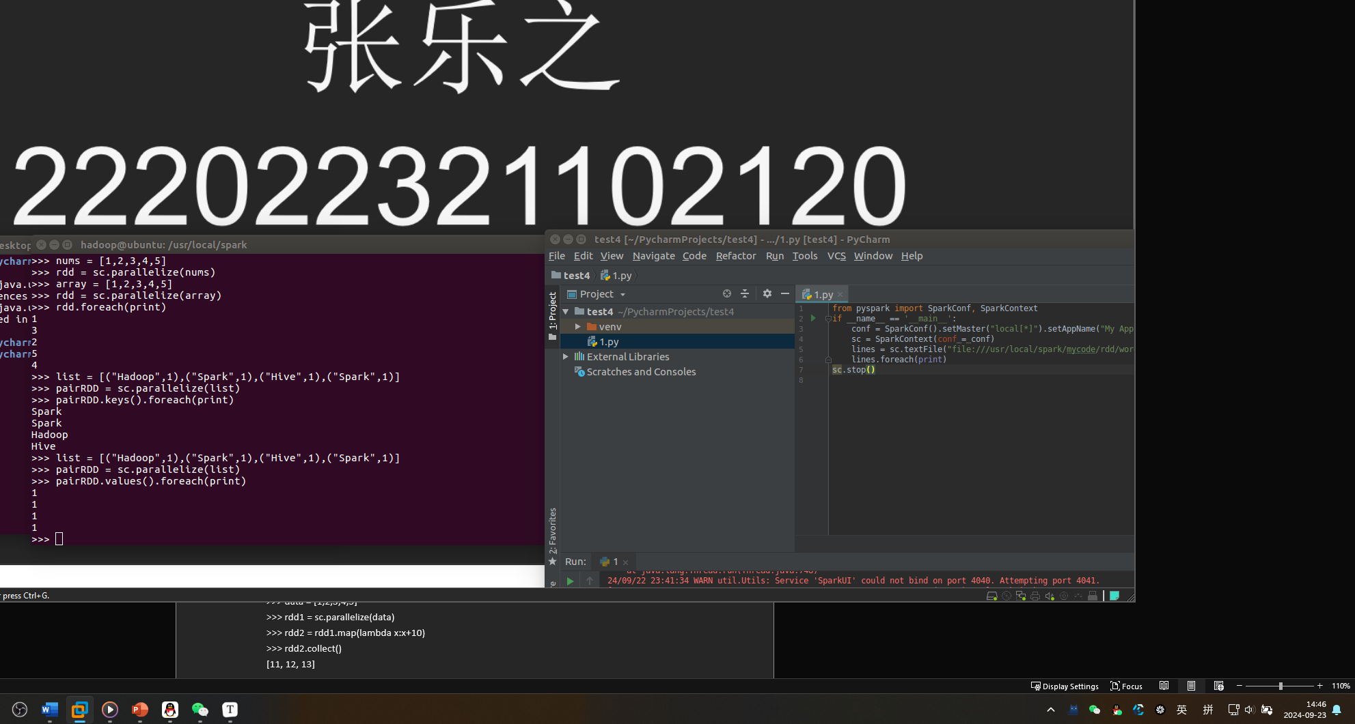

1. 转换操作

惰性机制所谓的“惰性机制”是指，整个转换过程只是记录了转换的轨迹，并不会发生真正的计算，只有遇到行动操作时，才会触发“从头到尾”的真正的计算

2、filter

>>> lines = sc.textFile("file:///usr/local/spark/mycode/rdd/word.txt")

>>> linesWithSpark = lines.filter(lambda line: "Spark" in line)

>>> linesWithSpark.foreach(print)

Spark is better

Spark is fast

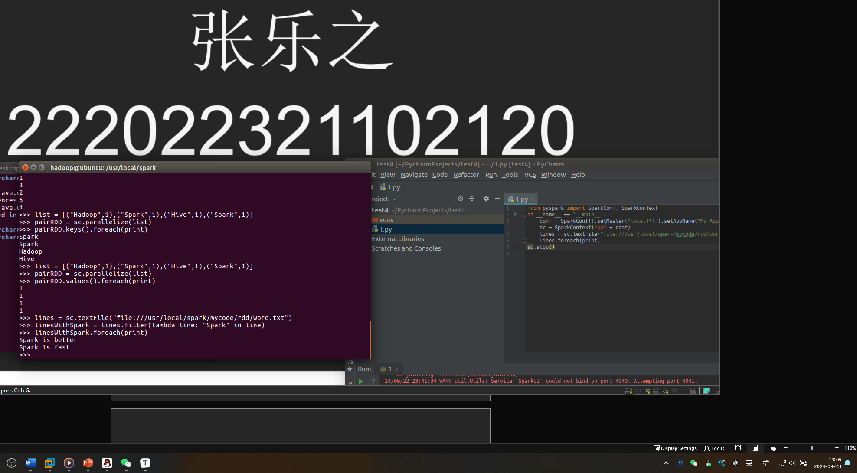

3、map

>>> data = [1,2,3,4,5]

>>> rdd1 = sc.parallelize(data)

>>> rdd2 = rdd1.map(lambda x:x+10)

>>> rdd2.collect()

[11, 12, 13]

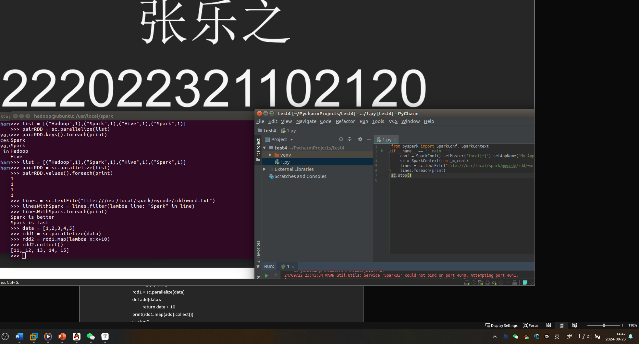

>>> lines = sc.textFile("file:///usr/local/spark/mycode/rdd/word.txt")

>>> words = lines.map(lambda line:line.split(" "))

>>> words.foreach(print)

['Hadoop', 'is', 'good']

['Spark', 'is', 'fast']

['Spark', 'is', 'better']

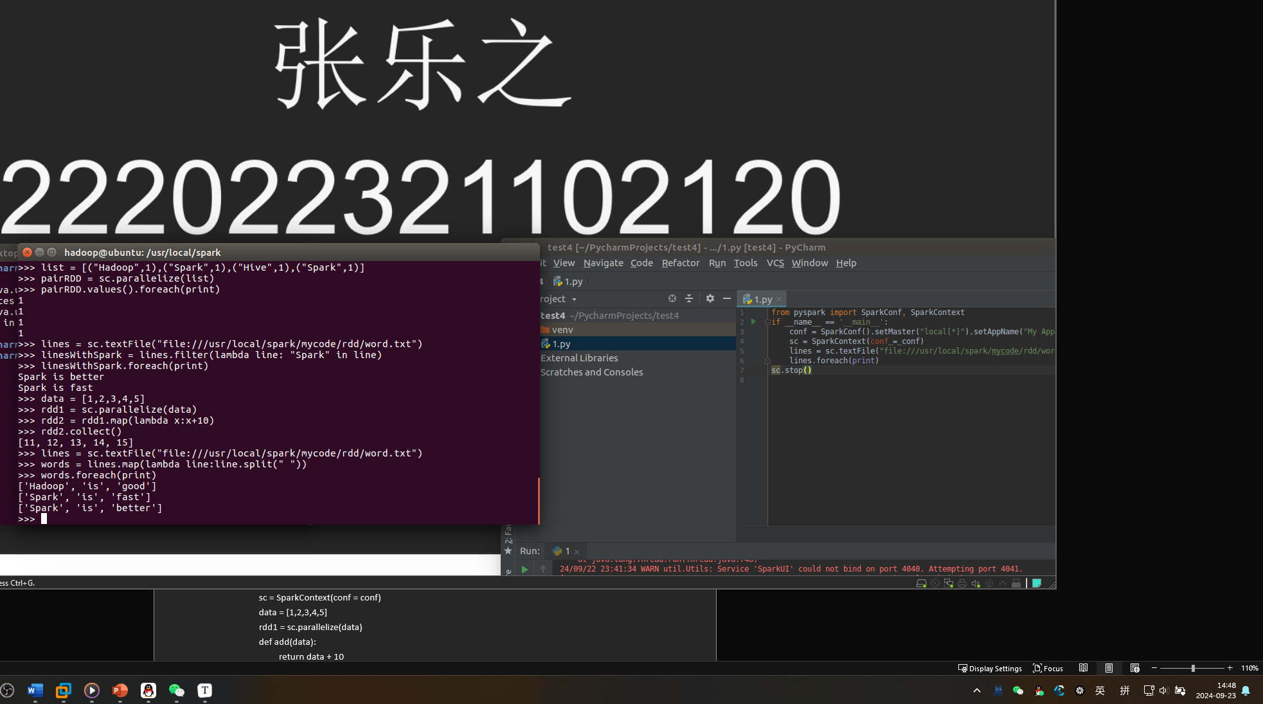

# coding:utf8

from pyspark import SparkConf, SparkContext

if __name__ == '__main__':

conf = SparkConf().setMaster("local[*]").setAppName("My App")

sc = SparkContext(conf = conf)

data = [1,2,3,4,5]

rdd1 = sc.parallelize(data)

def add(data):

return data + 10

print(rdd1.map(add).collect())

sc.stop()

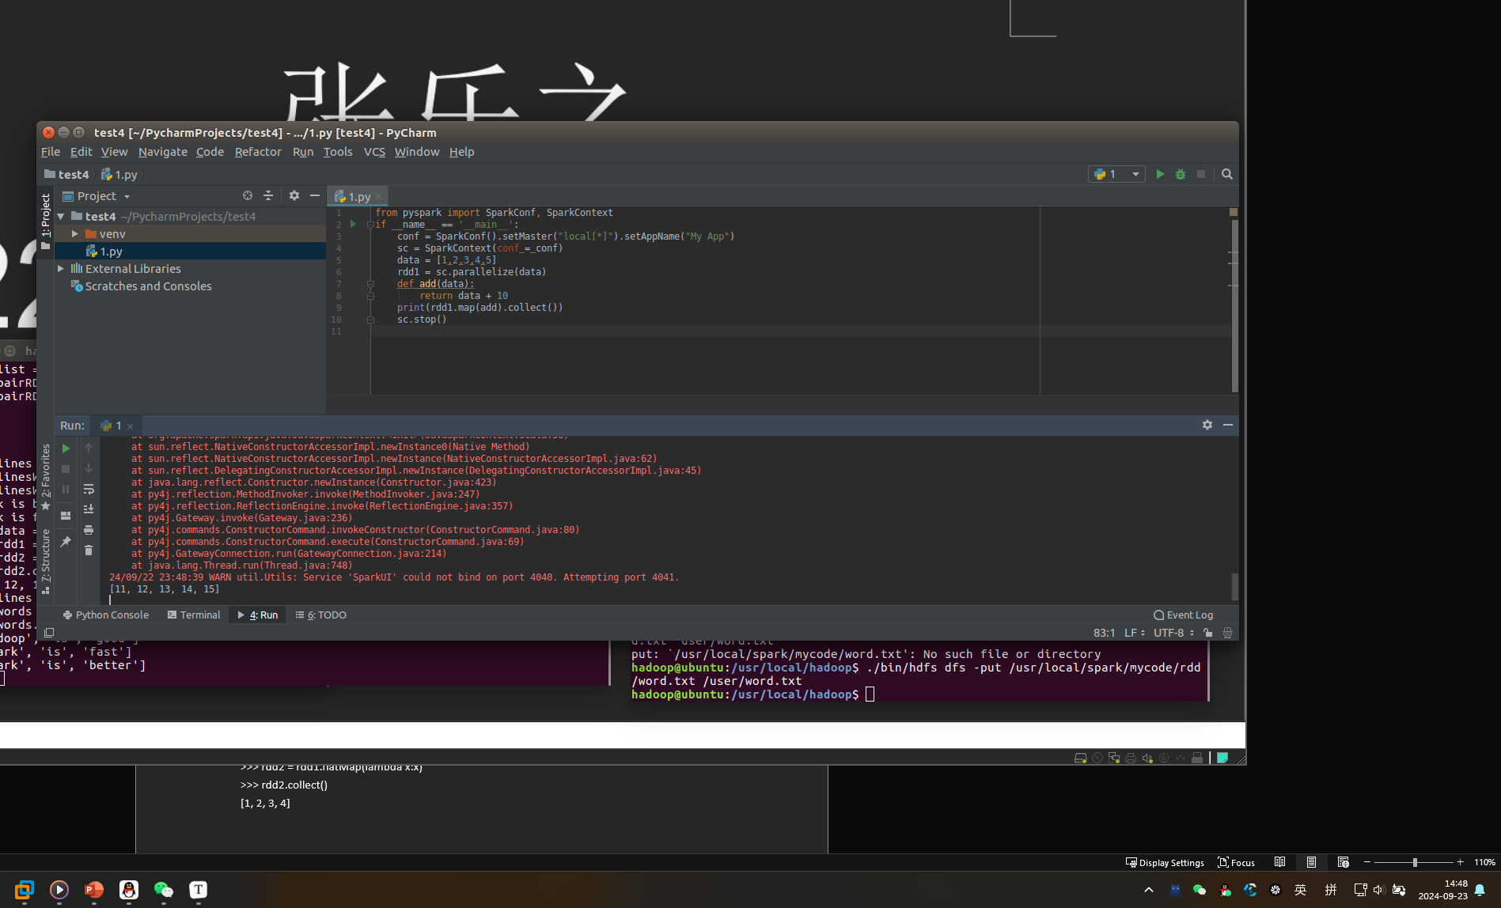

4、flatMap

>>> lines = sc.textFile("file:///usr/local/spark/mycode/rdd/word.txt")

>>> words = lines.flatMap(lambda line:line.split(" "))

>>> words.collect()

['Hadoop', 'is', 'good', 'Spark', 'is', 'fast', 'Spark', 'is', 'better']

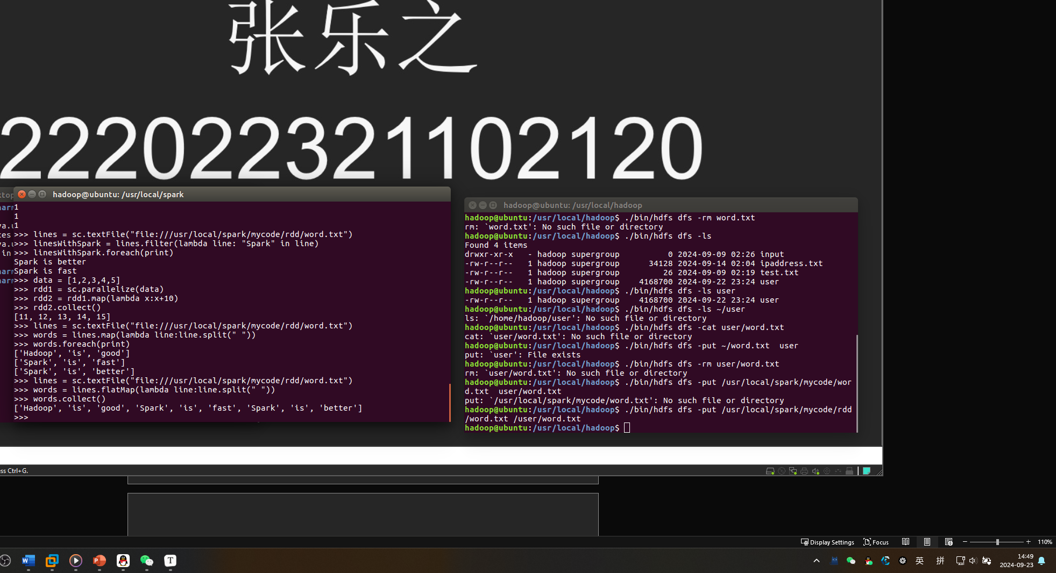

>>> rdd1 = sc.parallelize([[1,2], [3,4]])

>>> rdd2 = rdd1.flatMap(lambda x:x)

>>> rdd2.collect()

[1, 2, 3, 4]

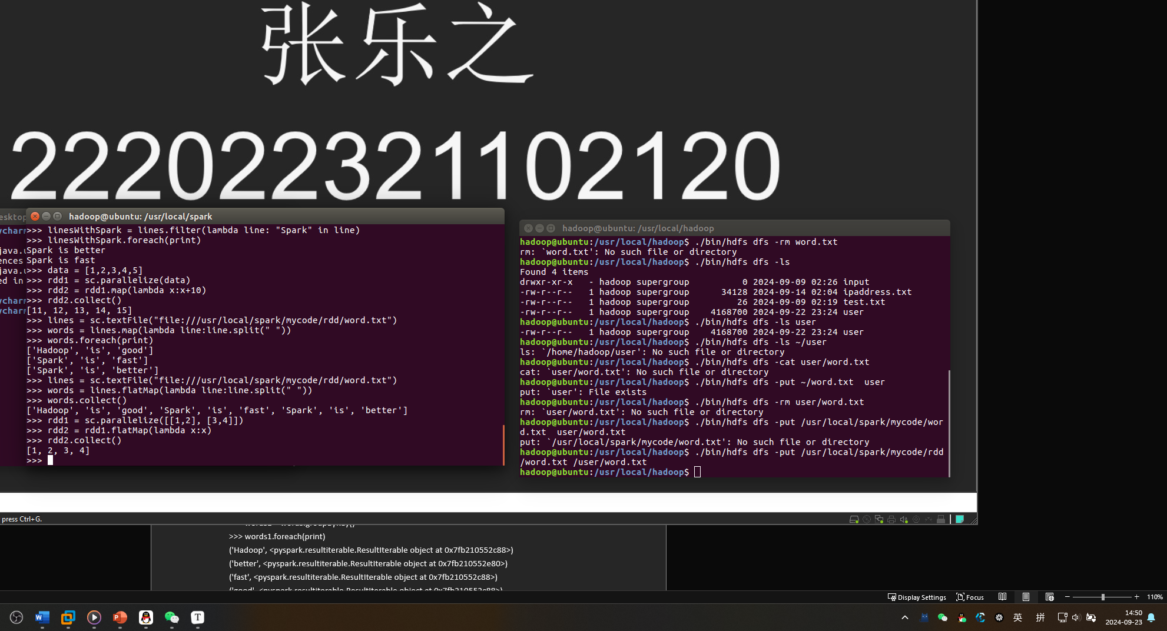

5、groupByKey

>>> words = sc.parallelize([("Hadoop",1),("is",1),("good",1), ("Spark",1),("is",1),("fast",1),("Spark",1),("is",1),("better",1)])

>>> words1 = words.groupByKey()

>>> words1.foreach(print)

('Hadoop', <pyspark.resultiterable.ResultIterable object at 0x7fb210552c88>)

('better', <pyspark.resultiterable.ResultIterable object at 0x7fb210552e80>)

('fast', <pyspark.resultiterable.ResultIterable object at 0x7fb210552c88>)

('good', <pyspark.resultiterable.ResultIterable object at 0x7fb210552c88>)

('Spark', <pyspark.resultiterable.ResultIterable object at 0x7fb210552f98>)

('is', <pyspark.resultiterable.ResultIterable object at 0x7fb210552e10>)

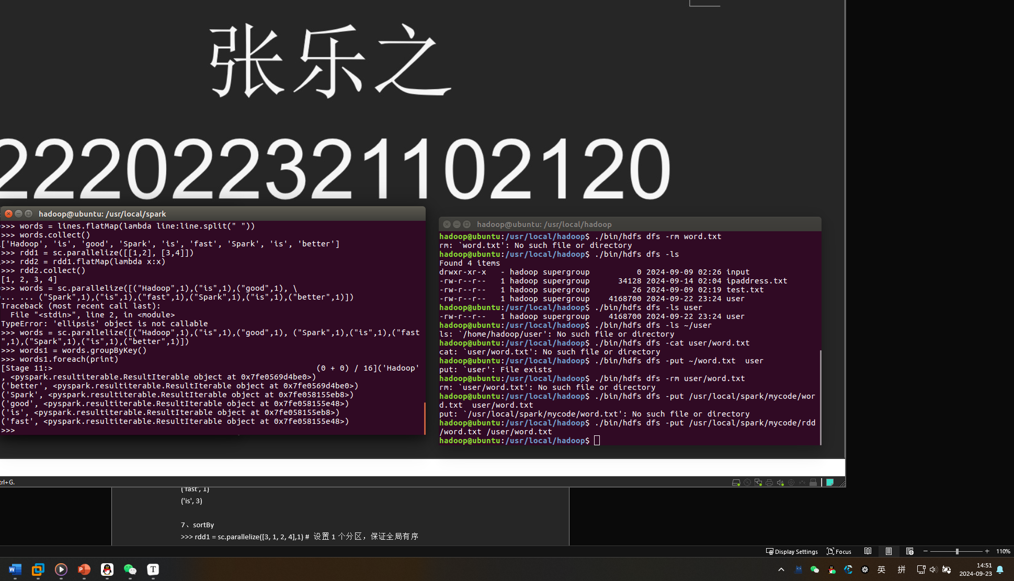

6、reduceByKey

>>> words = sc.parallelize([("Hadoop",1),("is",1),("good",1),("Spark",1), ("is",1),("fast",1),("Spark",1),("is",1),("better",1)])

>>> words1 = words.reduceByKey(lambda a,b:a+b)

>>> words1.foreach(print)

('good', 1)

('Hadoop', 1)

('better', 1)

('Spark', 2)

('fast', 1)

('is', 3)

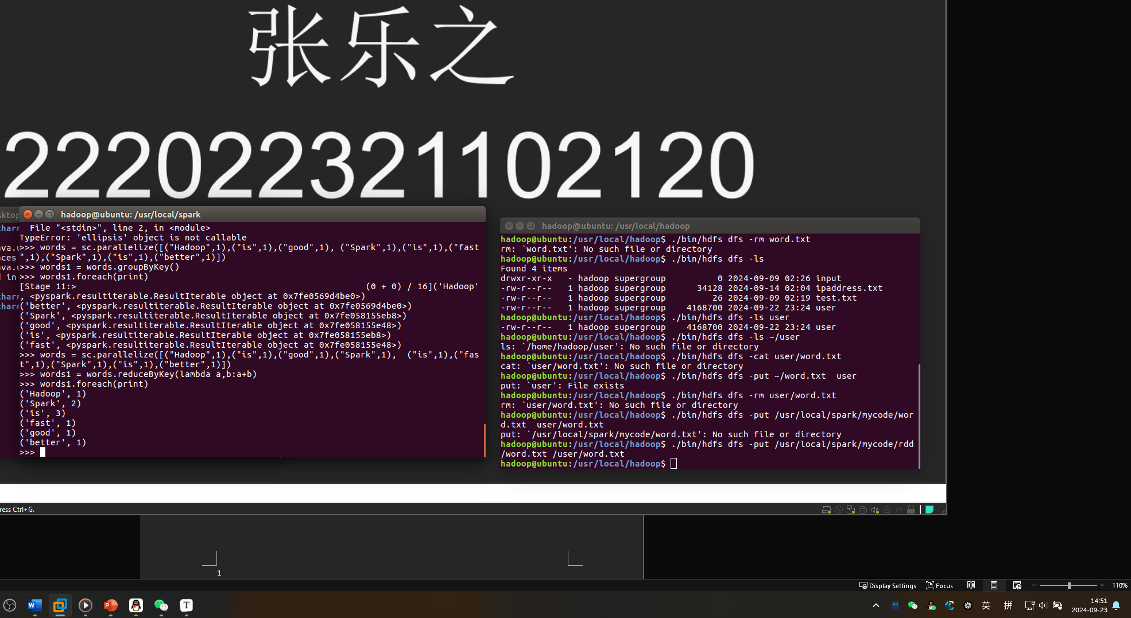

7、sortBy

>>> rdd1 = sc.parallelize([3, 1, 2, 4],1) # 设置1个分区，保证全局有序

>>> rdd2 = rdd1.sortBy(lambda x:x)

>>> rdd2.foreach(print)

1

2

3

4

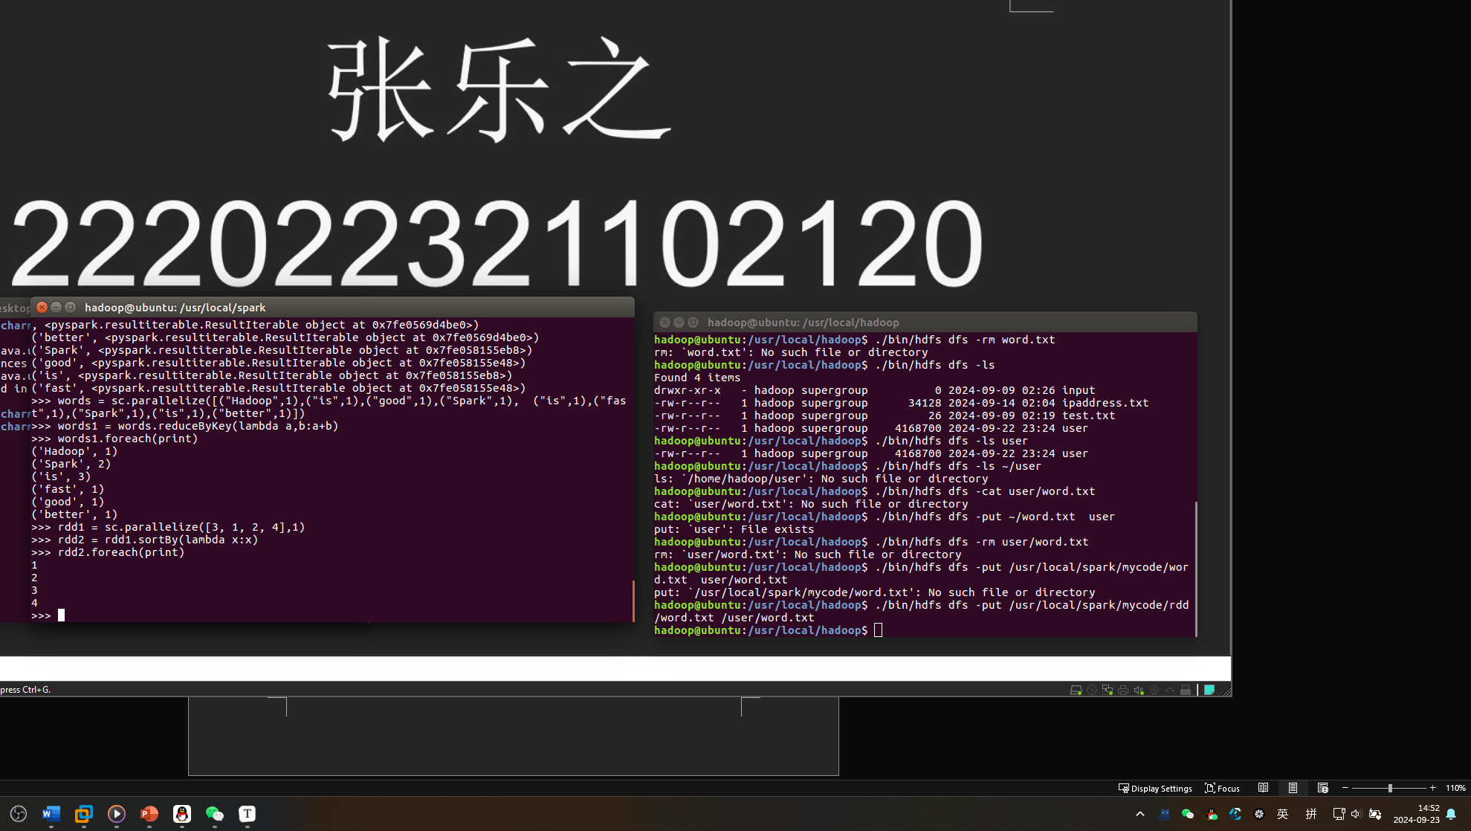

>>> rdd2 = rdd1.sortBy(lambda x:x,False) #使用参数False，实现降序排序

>>> rdd2.foreach(print)

4

3

2

1 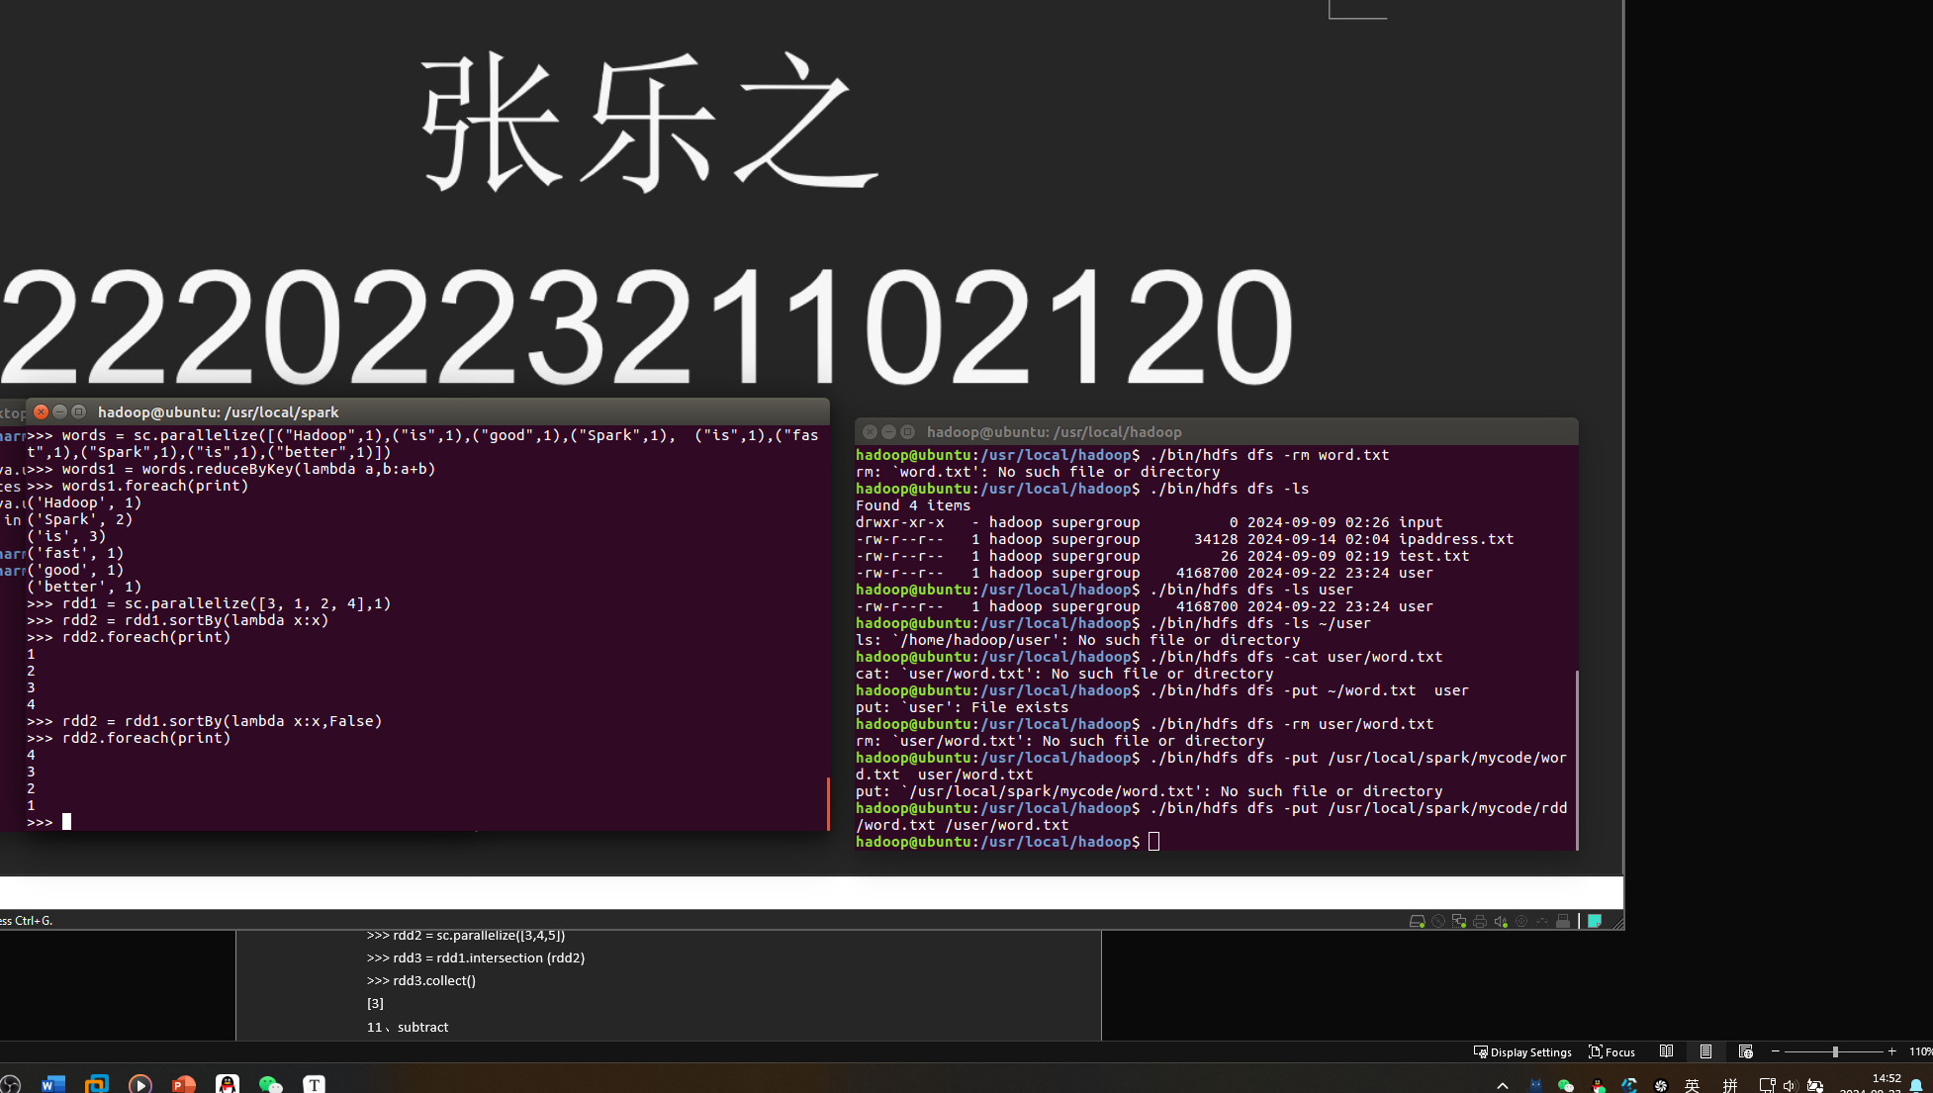

8、distinc

>>> rdd1 = sc.parallelize(["Flink","Spark","Spark"])

>>> rdd2 = rdd1.distinct()

>>> rdd2.foreach(print)

Flink

Spark

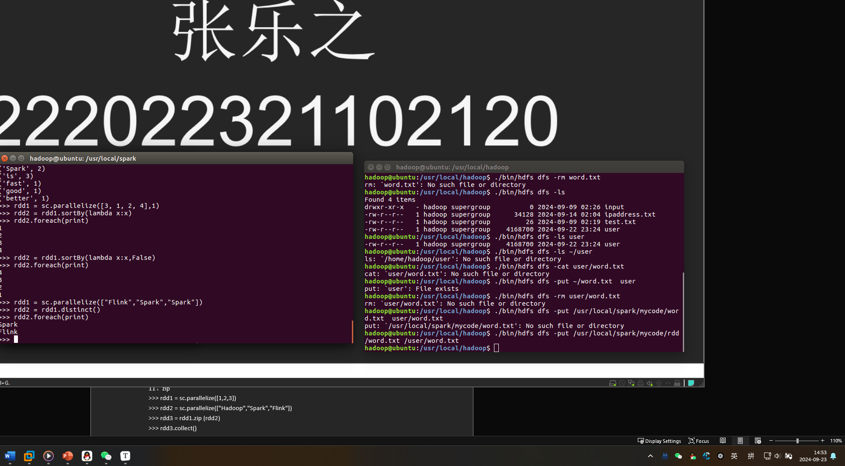

9、union

>>> rdd1 = sc.parallelize([1,2,3])

>>> rdd2 = sc.parallelize([3,4,5])

>>> rdd3 = rdd1.union(rdd2)

>>> rdd3.collect()

[1, 2, 3, 3, 4, 5]

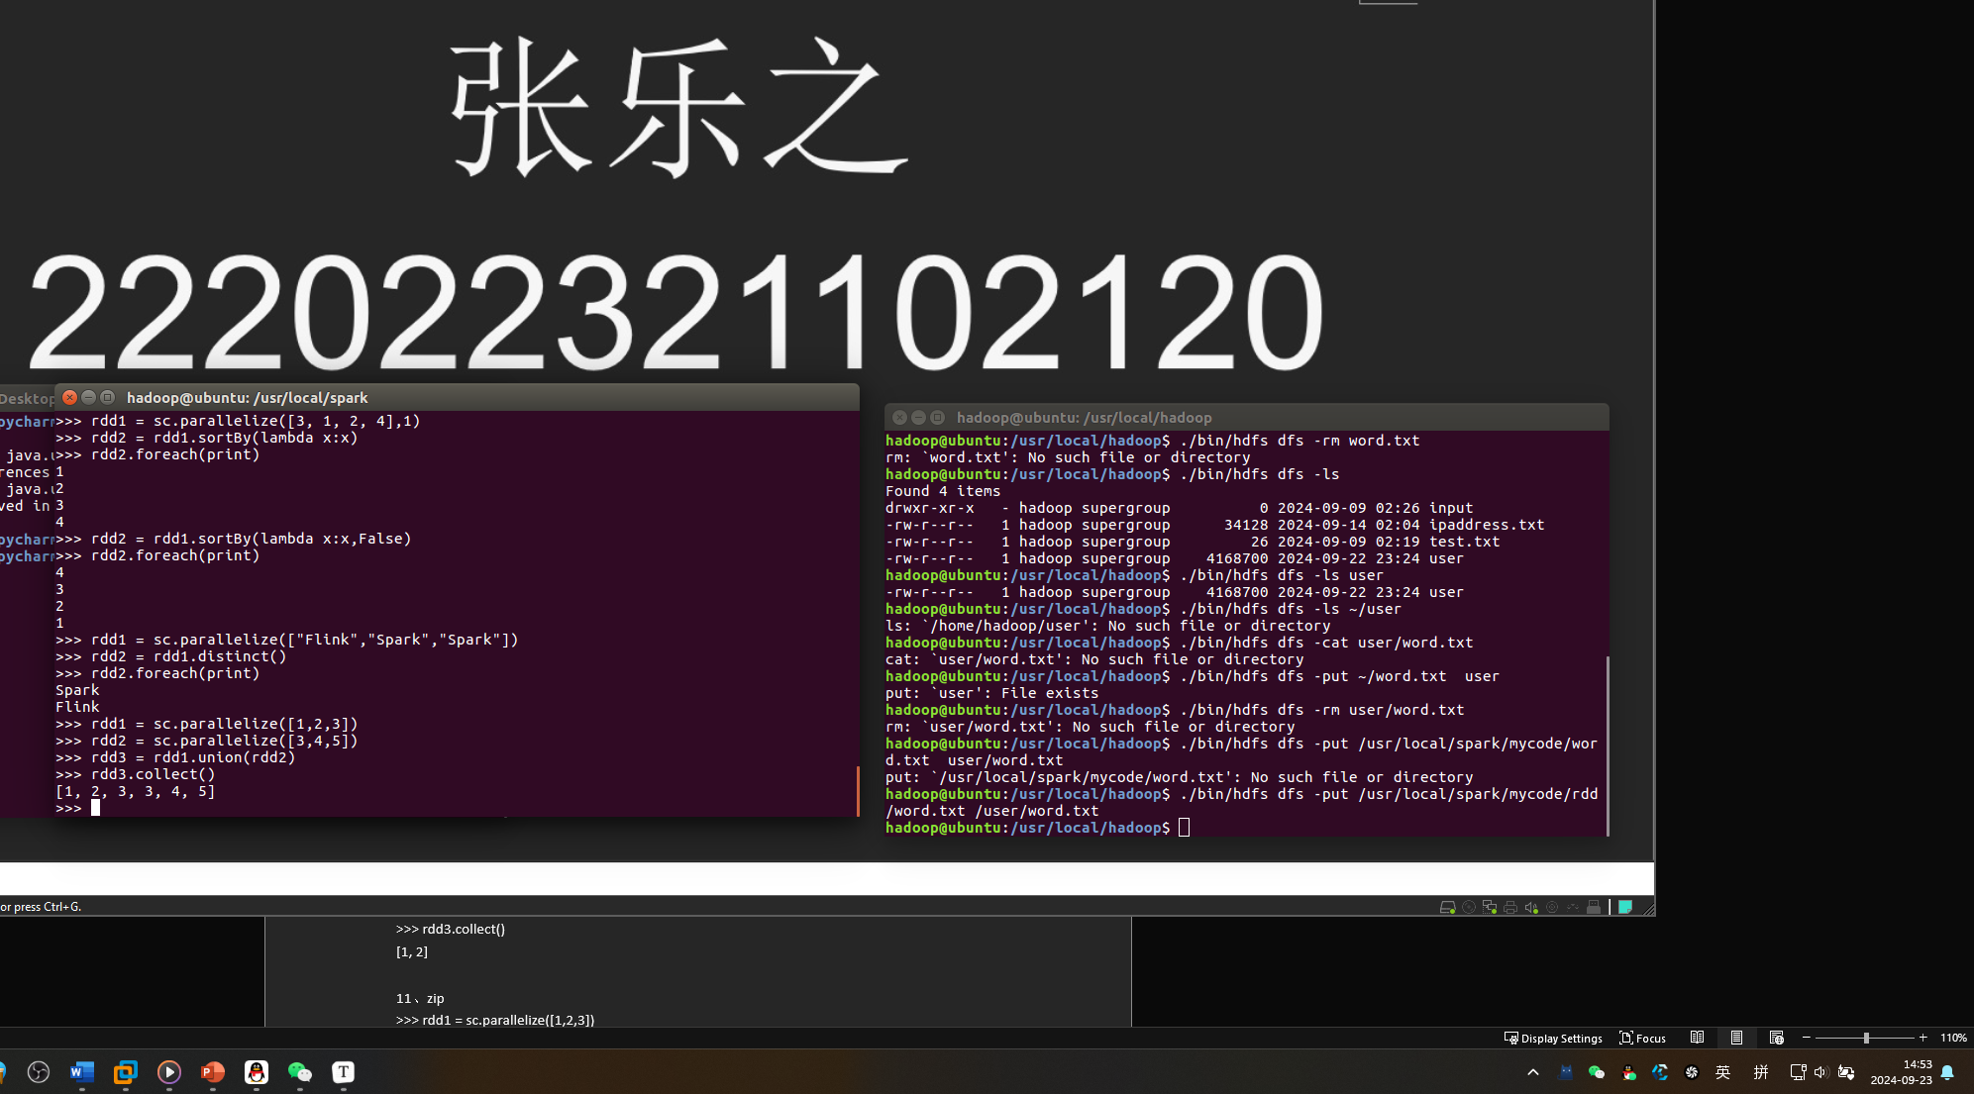

10、intersection

>>> rdd1 = sc.parallelize([1,2,3])

>>> rdd2 = sc.parallelize([3,4,5])

>>> rdd3 = rdd1.intersection (rdd2)

>>> rdd3.collect()

[3]

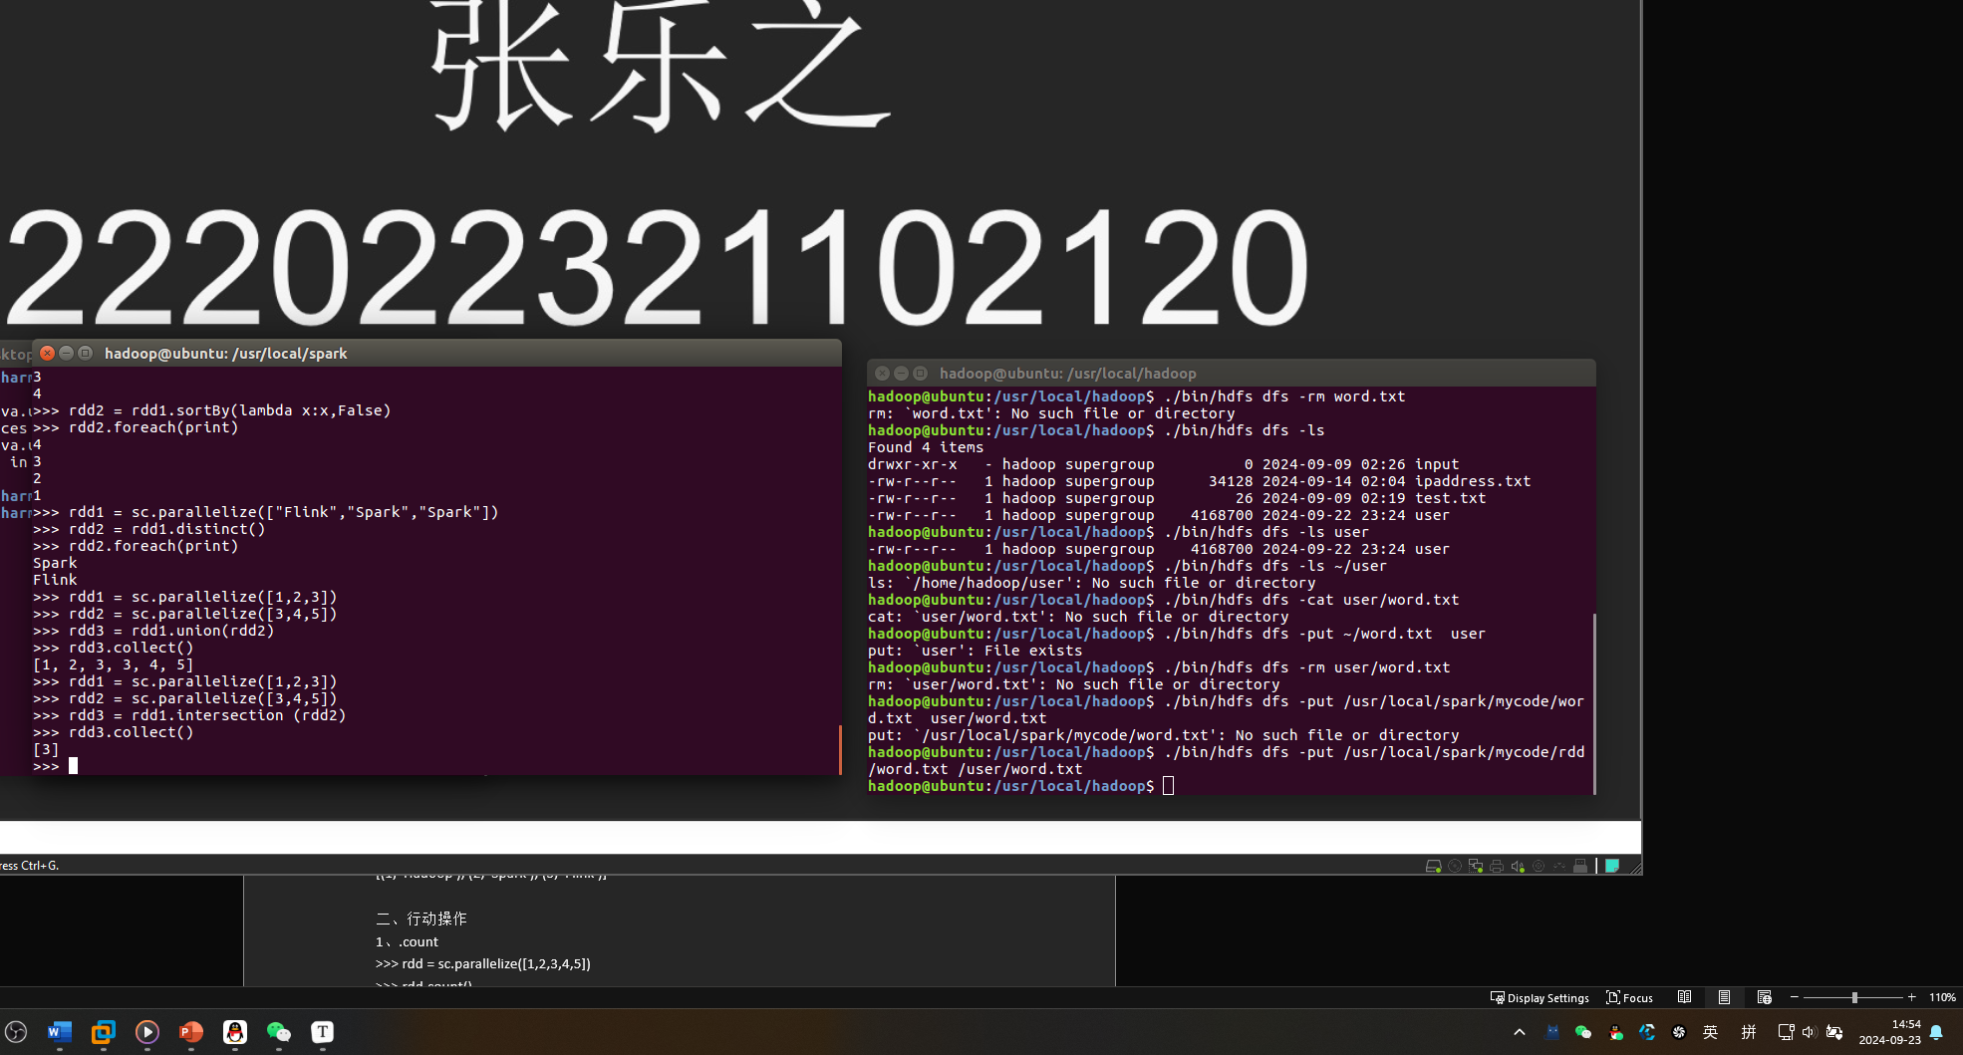

11、subtract

>>> rdd1 = sc.parallelize([1,2,3])

>>> rdd2 = sc.parallelize([3,4,5])

>>> rdd3 = rdd1.subtract (rdd2)

>>> rdd3.collect()

[1, 2]

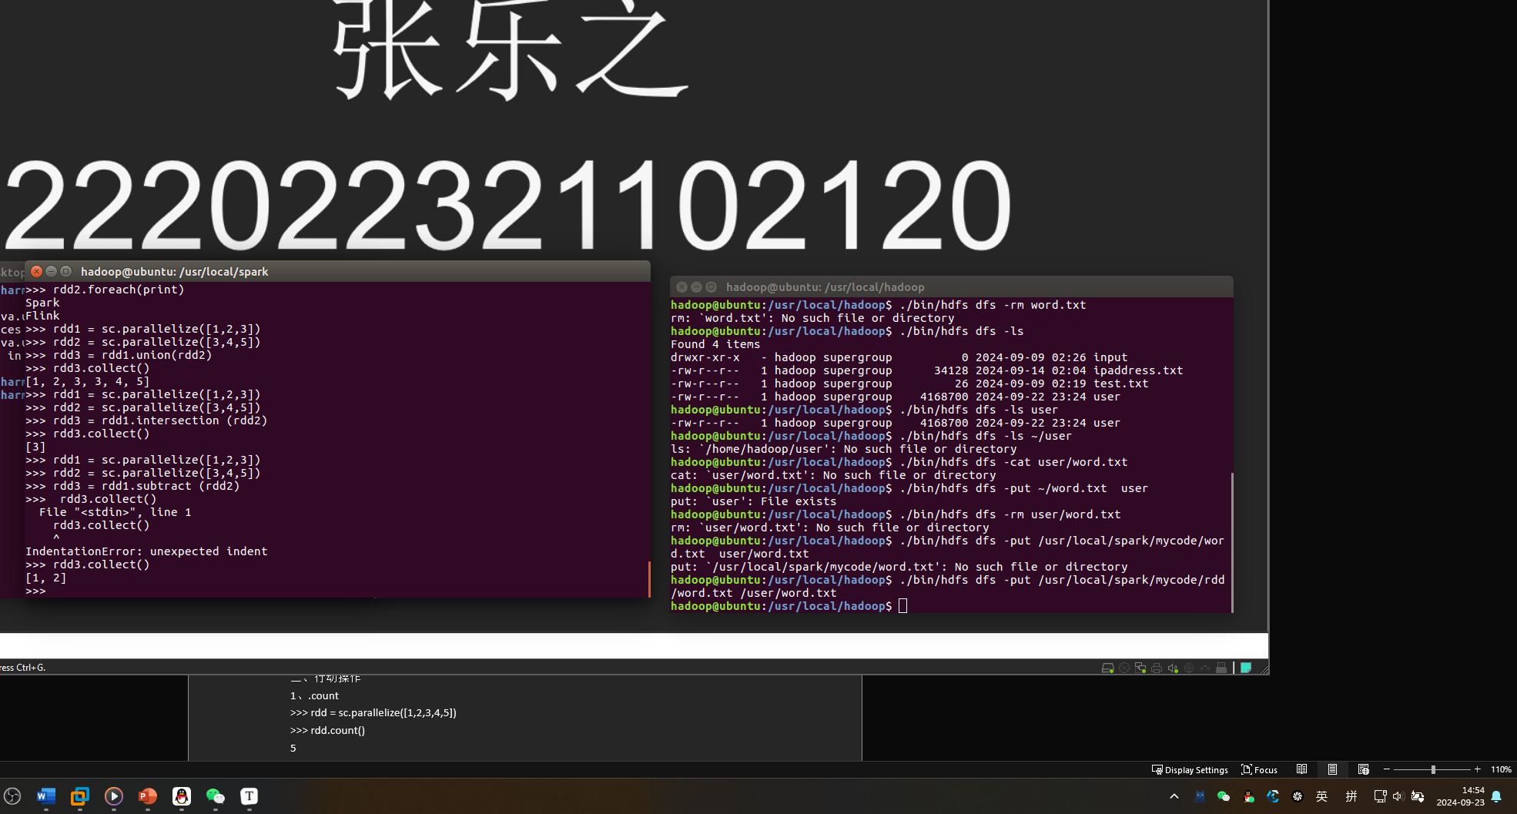

11、zip

>>> rdd1 = sc.parallelize([1,2,3])

>>> rdd2 = sc.parallelize(["Hadoop","Spark","Flink"])

>>> rdd3 = rdd1.zip (rdd2)

>>> rdd3.collect()

[(1, 'Hadoop'), (2, 'Spark'), (3, 'Flink')]

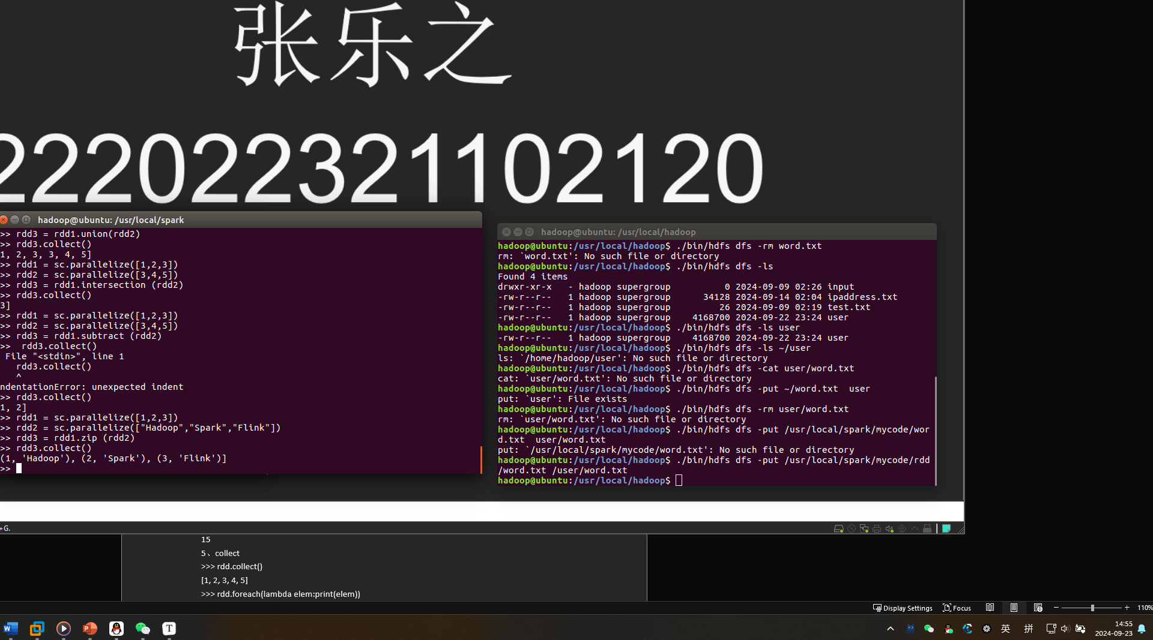

二、行动操作

1、.count

>>> rdd = sc.parallelize([1,2,3,4,5])

>>> rdd.count()

5

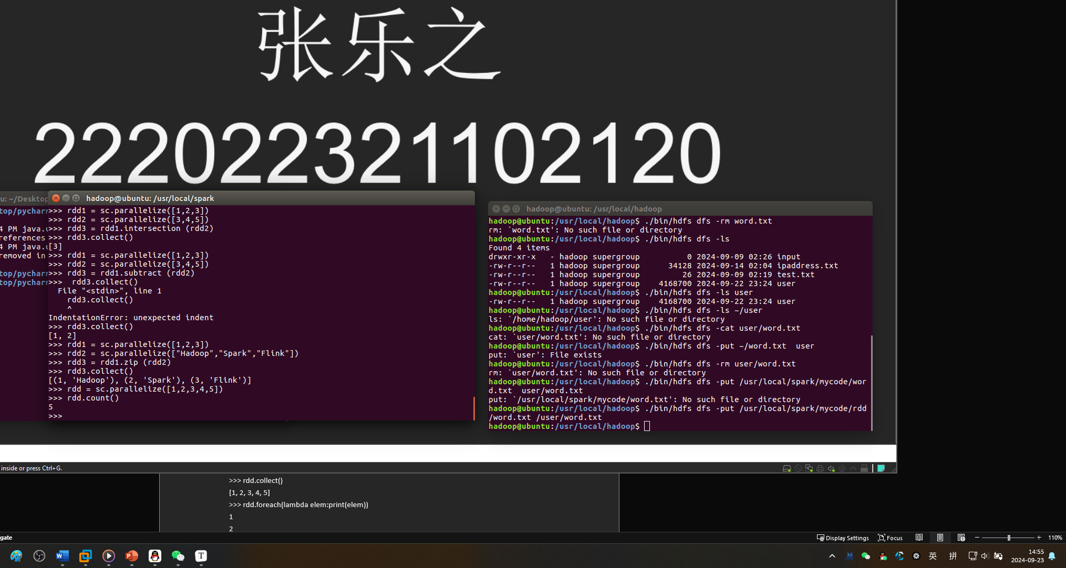

1. first

>>> rdd.first()

1

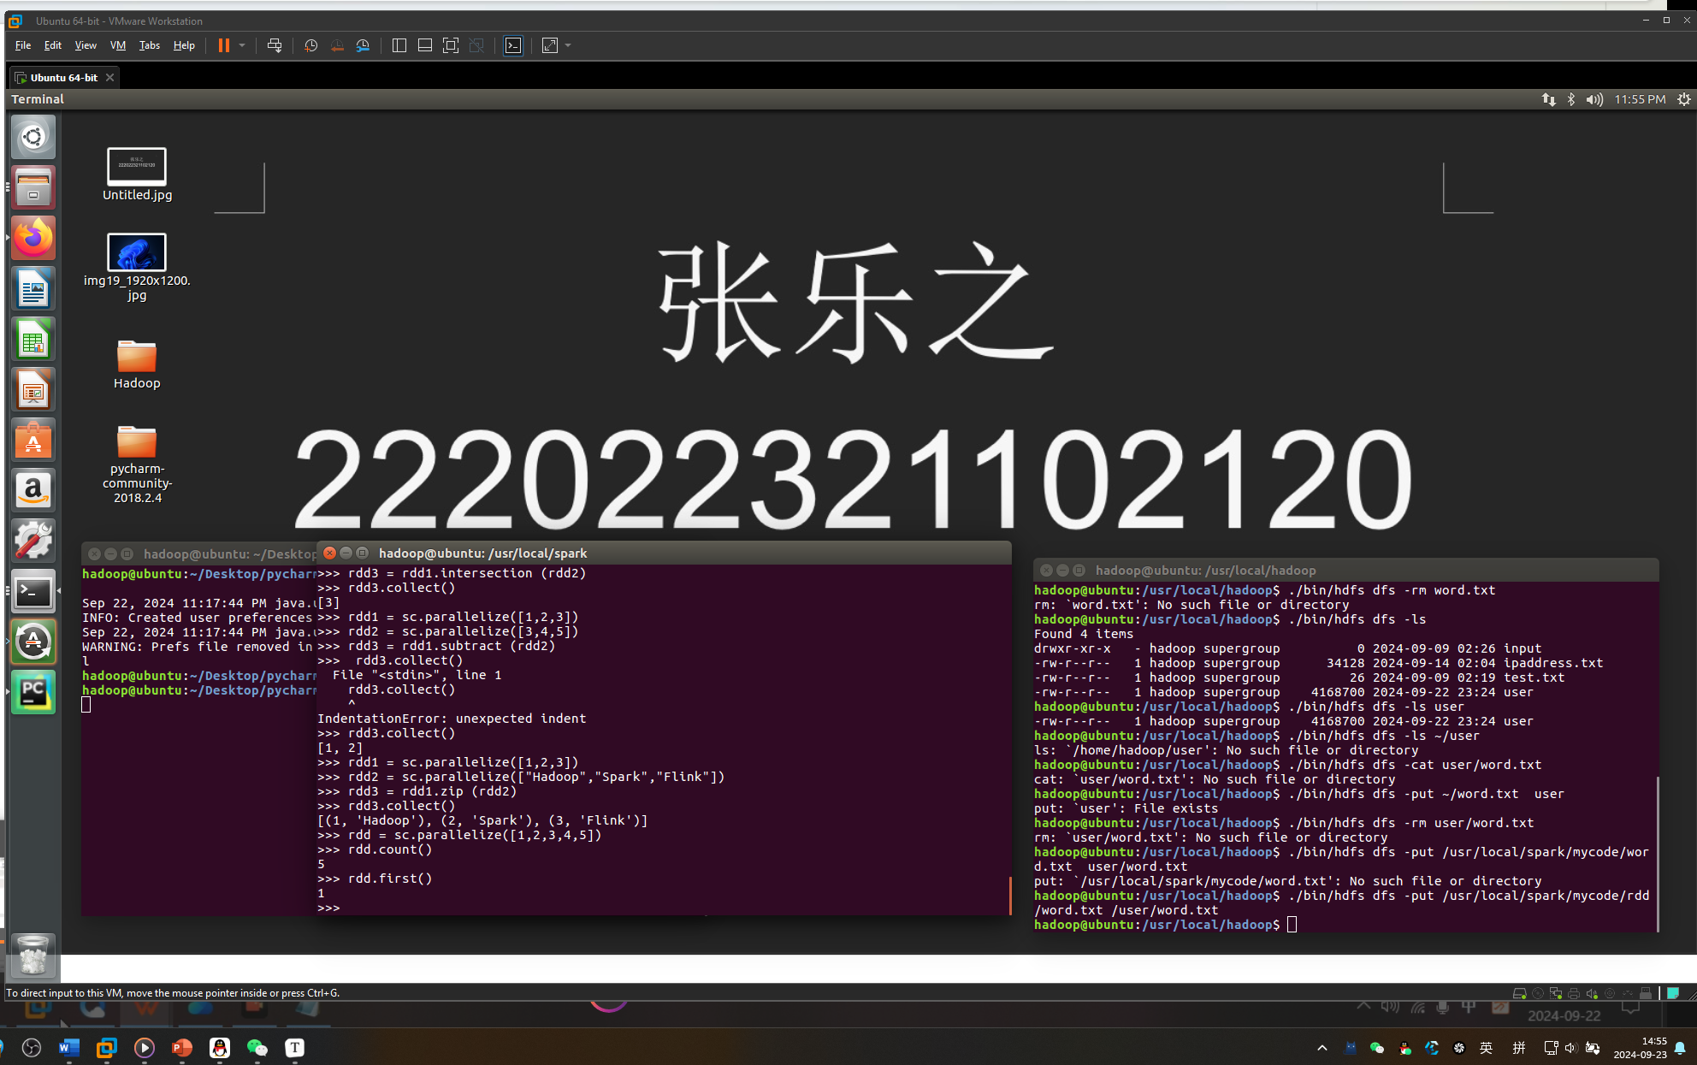

3、take

>>> rdd.take(3)

[1, 2, 3]

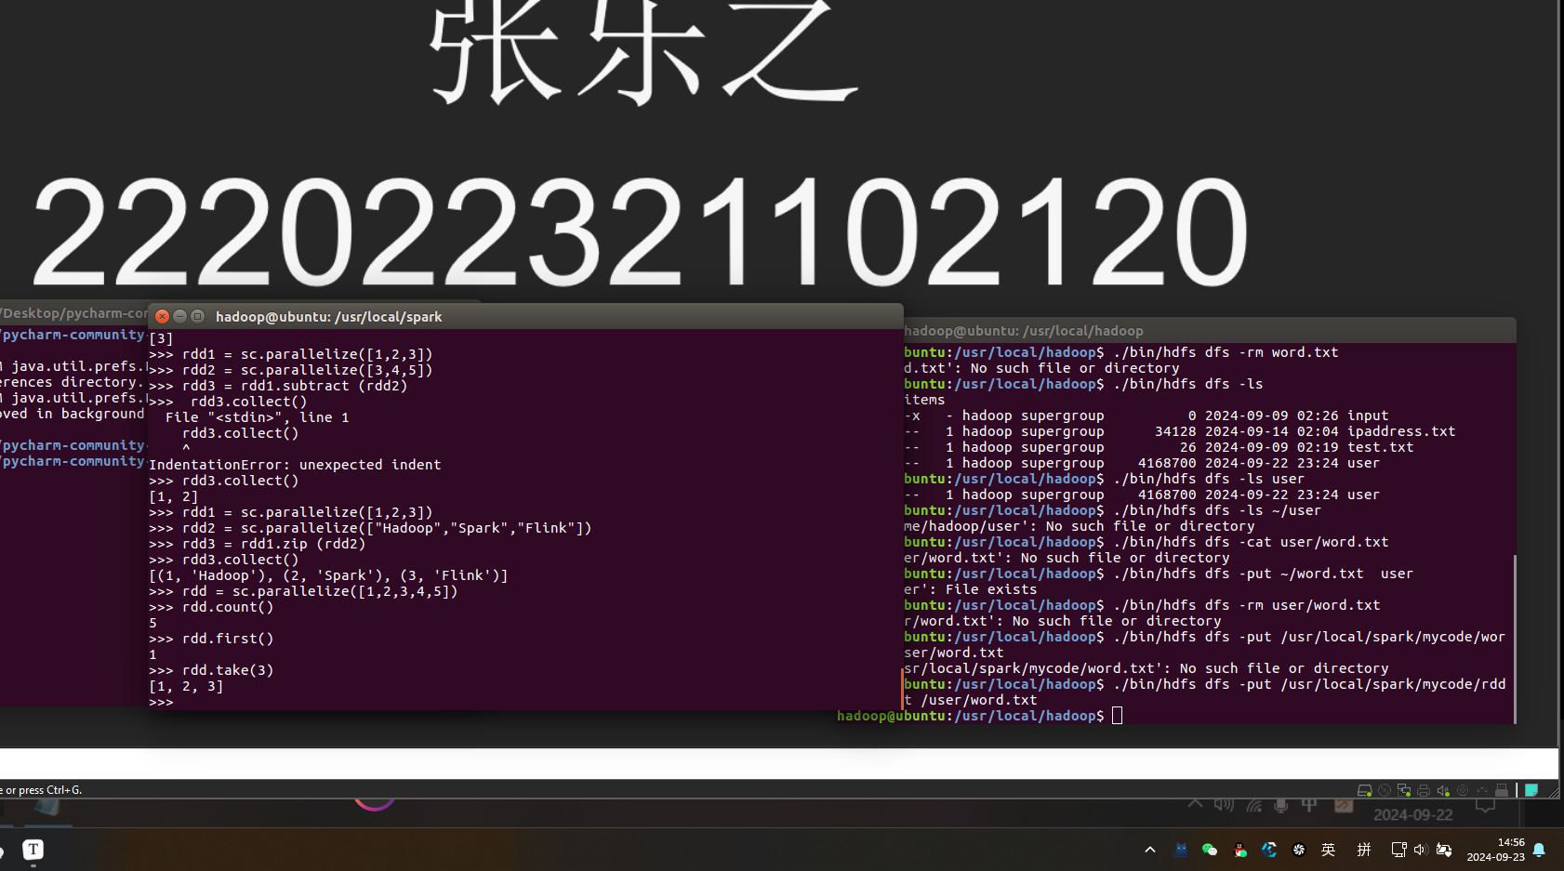

4、reduce

>>> rdd.reduce(lambda a,b:a+b)

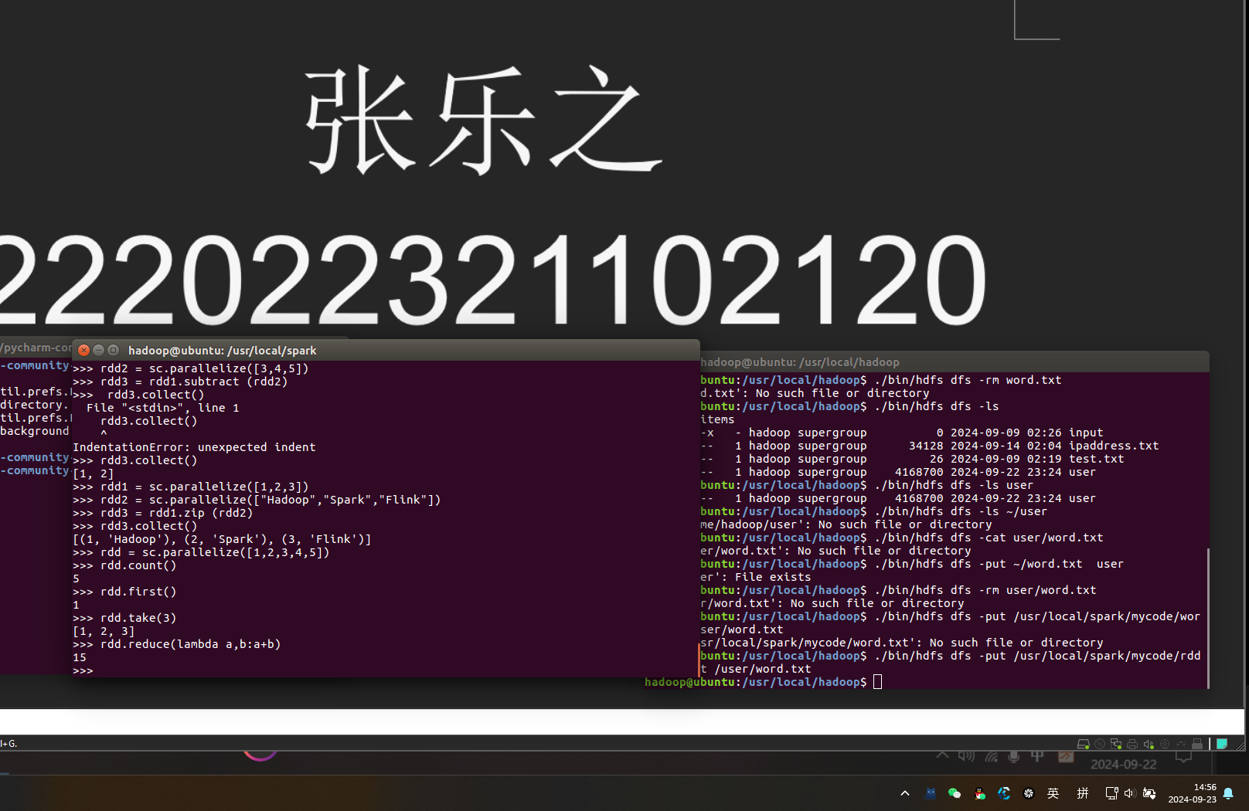

15

5、collect

>>> rdd.collect()

[1, 2, 3, 4, 5]

>>> rdd.foreach(lambda elem:print(elem))

1

2

3

4

5

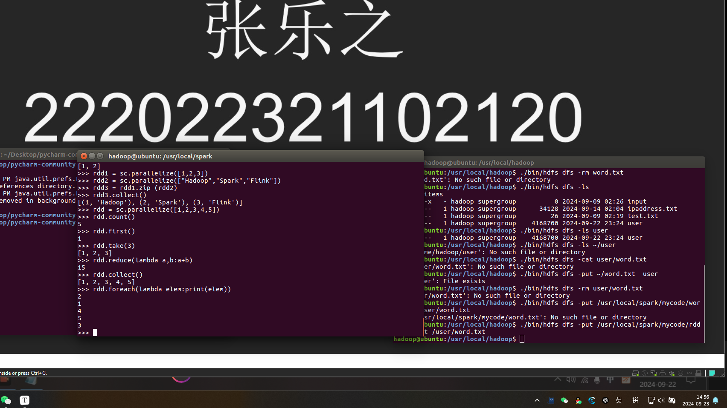

6、countByKey()

>>> rdd = sc.parallelize([("hadoop",1),("spark",1),("spark",1)])

>>> result = rdd.countByKey()

>>> print(result)

defaultdict(<class 'int'>, {'hadoop': 1, 'spark': 2})

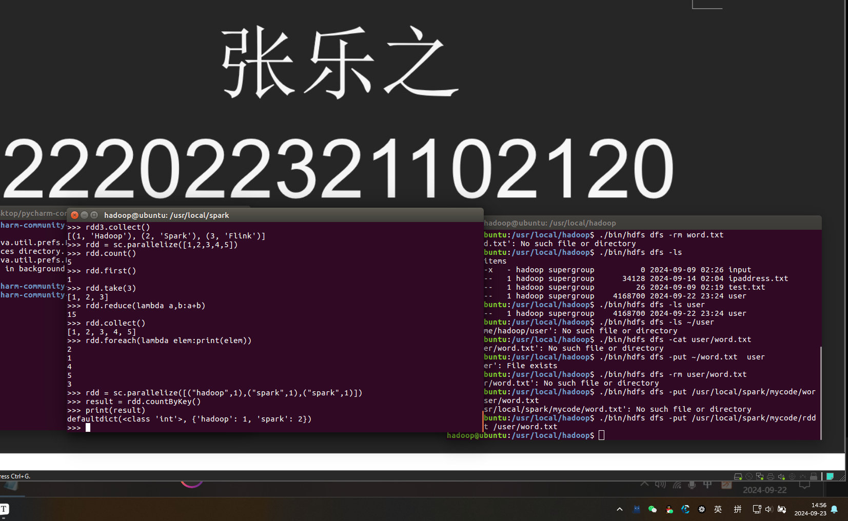

7、aggregate

>>> rdd1 = sc.parallelize([1, 2, 3, 4], 2)

>>> result = rdd1.aggregate(0,lambda a,b:a+b,lambda a,b:a+b)

>>> print(result)

10

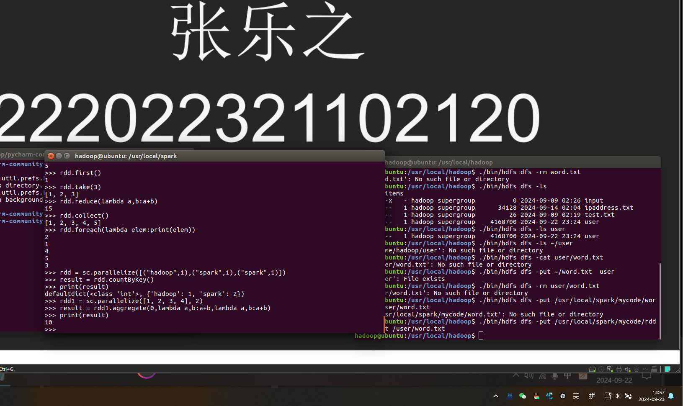

>>> lines = sc.textFile("file:///usr/local/spark/mycode/rdd/word.txt")

>>> lineLengths = lines.map(lambda s:len(s))

>>> totalLength = lineLengths.reduce(lambda a,b:a+b)

>>> print(totalLength)

42

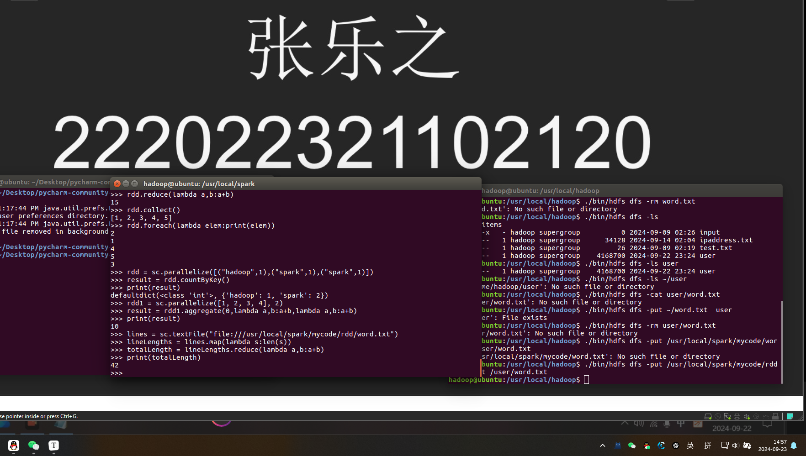

键值操作

1. groupByKey()

>>> list = [("spark",1),("spark",2),("hadoop",3),("hadoop",5)]

>>> pairRDD = sc.parallelize(list)

>>> pairRDD.groupByKey()

PythonRDD[27] at RDD at PythonRDD.scala:48

>>> pairRDD.groupByKey().foreach(print)

('hadoop', <pyspark.resultiterable.ResultIterable object at 0x7f2c1093ecf8>)

('spark', <pyspark.resultiterable.ResultIterable object at 0x7f2c1093ecf8>)

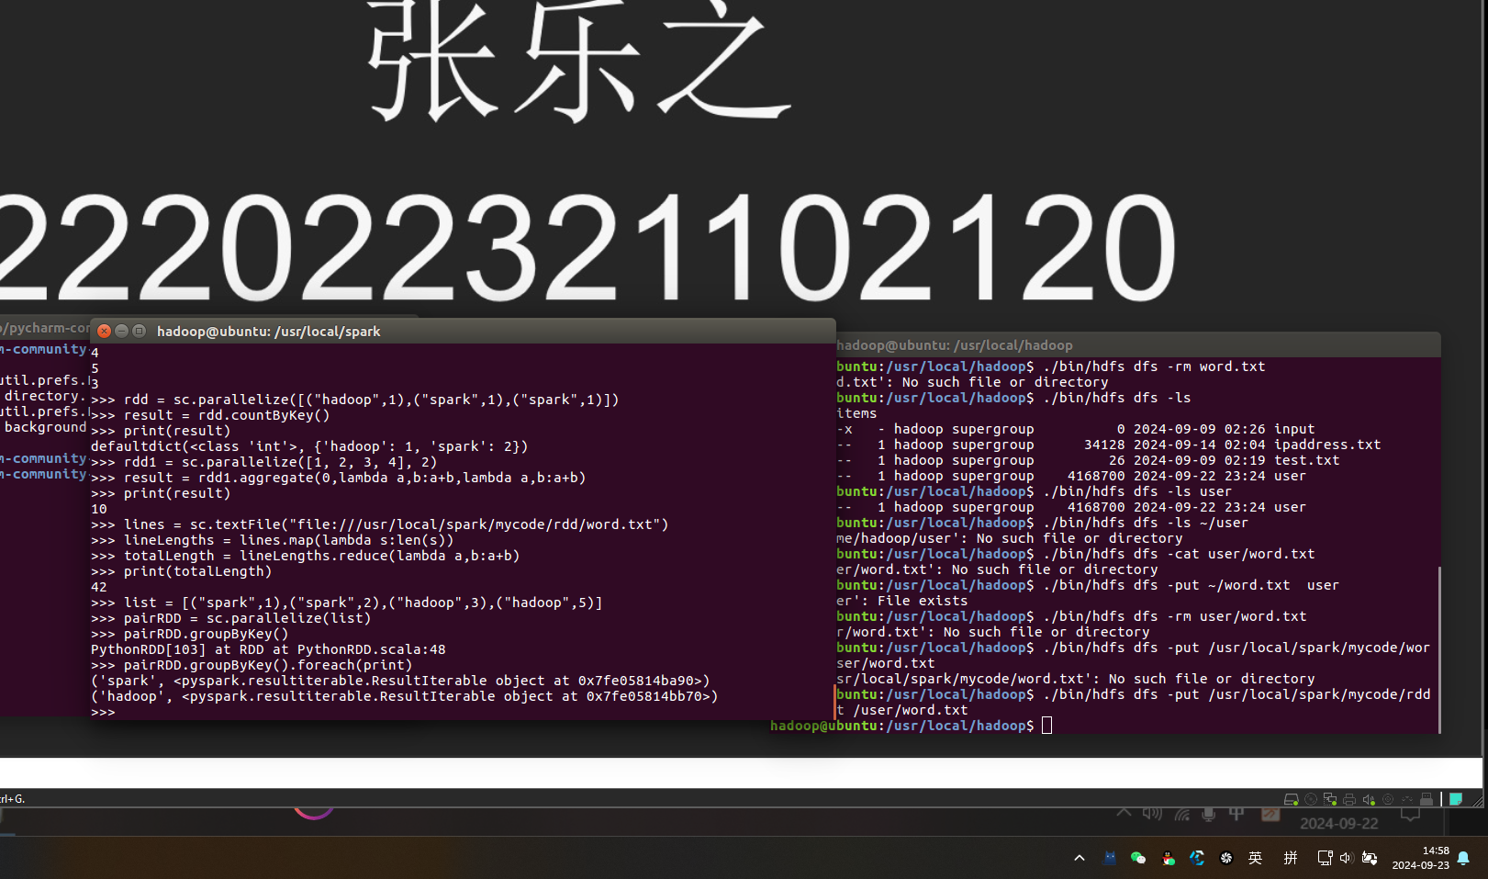

1. reduceByKey(func)

>>> words = ["one", "two", "two", "three", "three", "three"]

>>> wordPairsRDD = sc.parallelize(words).map(lambda word:(word, 1))

>>> wordCountsWithReduce = wordPairsRDD.reduceByKey(lambda a,b:a+b)

>>> wordCountsWithReduce.foreach(print)

('one', 1)

('two', 2)

('three', 3)

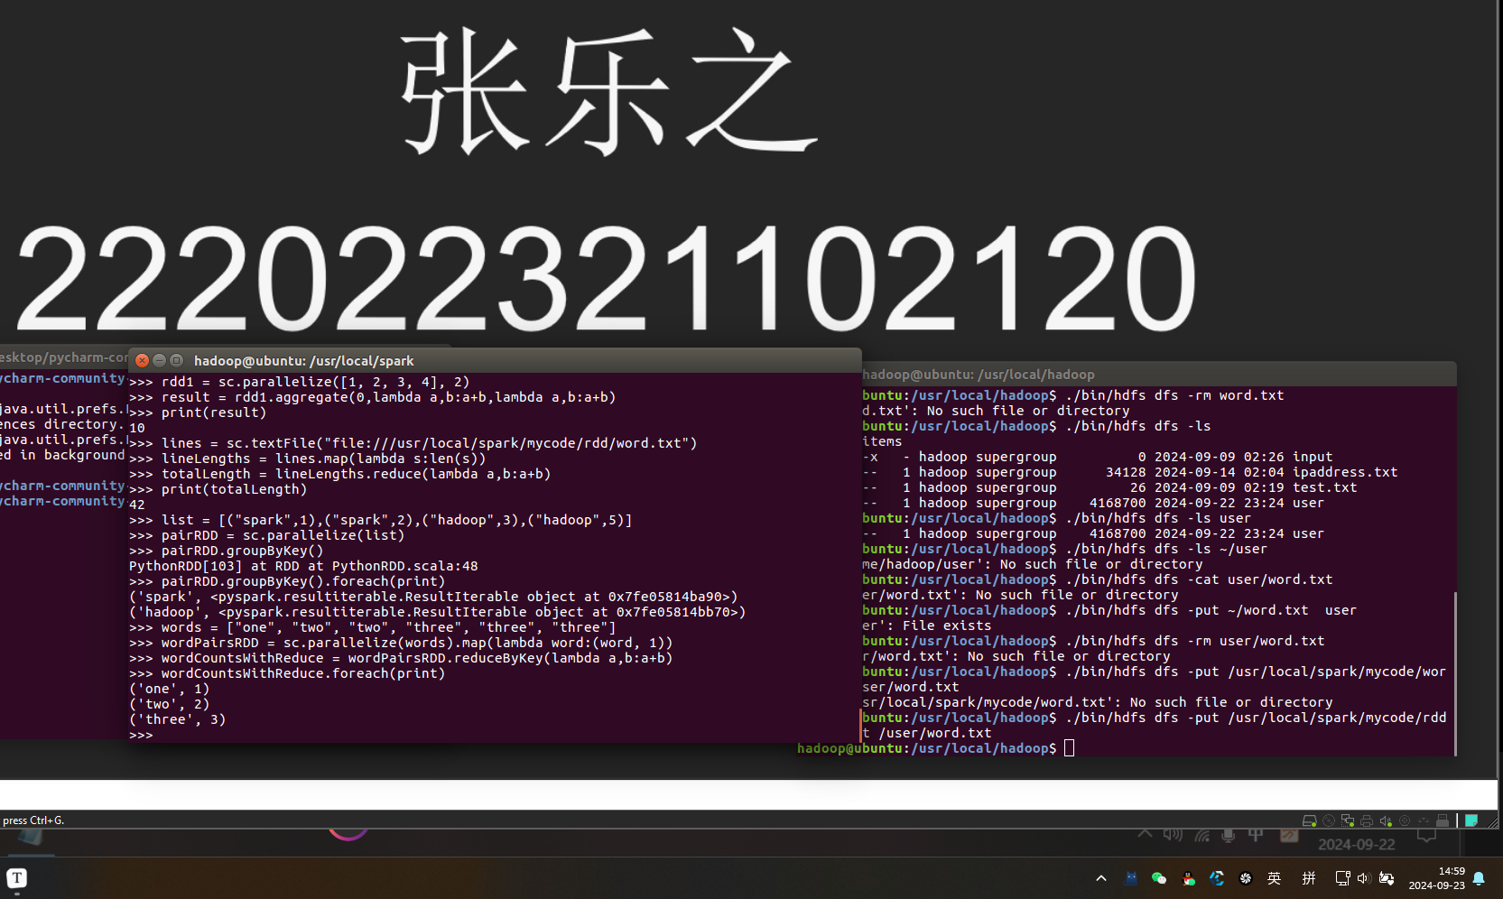

3、sortByKey

>>> list = [("Hadoop",1),("Spark",1),("Hive",1),("Spark",1)]

>>> pairRDD = sc.parallelize(list)

>>> pairRDD.foreach(print)

('Hadoop', 1)

('Spark', 1)

('Hive', 1)

('Spark', 1)

>>> pairRDD.sortByKey().foreach(print)

('Hadoop', 1)

('Hive', 1)

('Spark', 1)

('Spark', 1)

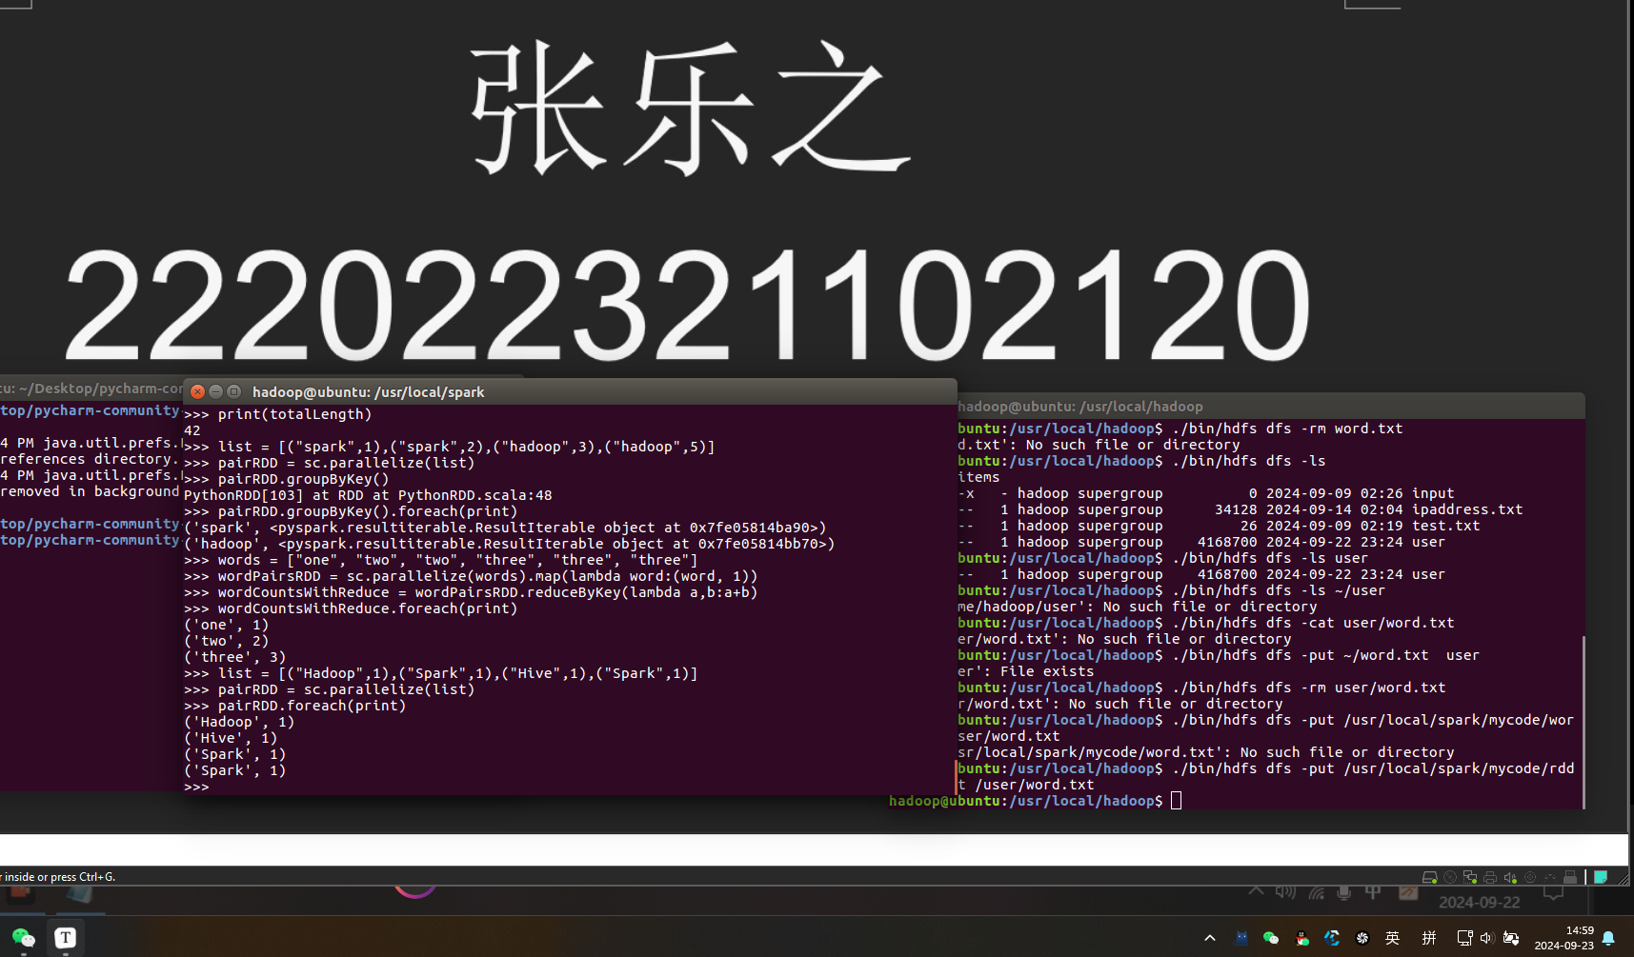

4、mapValues

>>> list = [("Hadoop",1),("Spark",1),("Hive",1),("Spark",1)]

>>> pairRDD = sc.parallelize(list)

>>> pairRDD1 = pairRDD.mapValues(lambda x:x+1)

>>> pairRDD1.foreach(print)

('Hadoop', 2)

('Spark', 2)

('Hive', 2)

('Spark', 2)

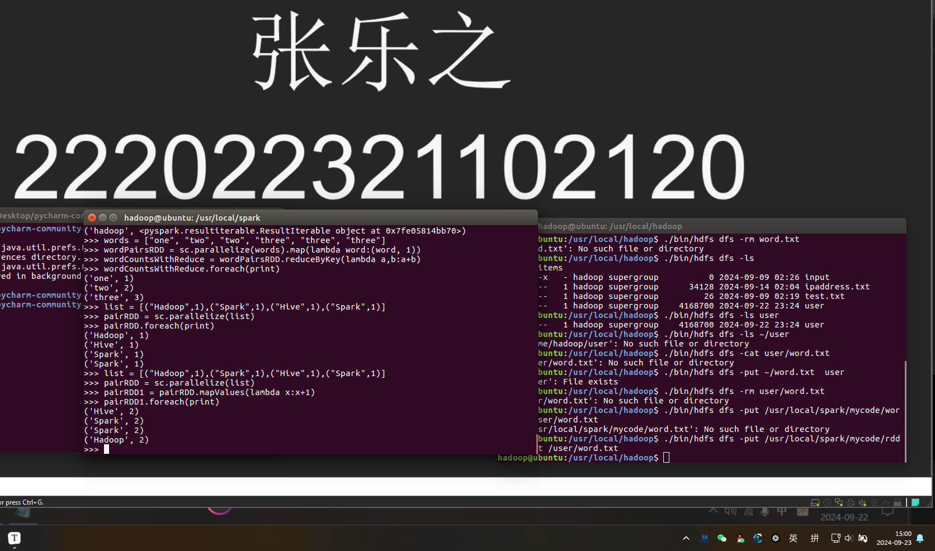

5、join，表示内连接，输入（k,V1), (K,V2), 输出（k,(V1,V2))

>>> pairRDD1 = sc. parallelize([("spark",1),("spark",2),("hadoop",3),("hadoop",5)])

>>> pairRDD2 = sc.parallelize([("spark","fast")])

>>> pairRDD3 = pairRDD1.join(pairRDD2)

>>> pairRDD3.foreach(print)

('spark', (1, 'fast'))

('spark', (2, 'fast'))

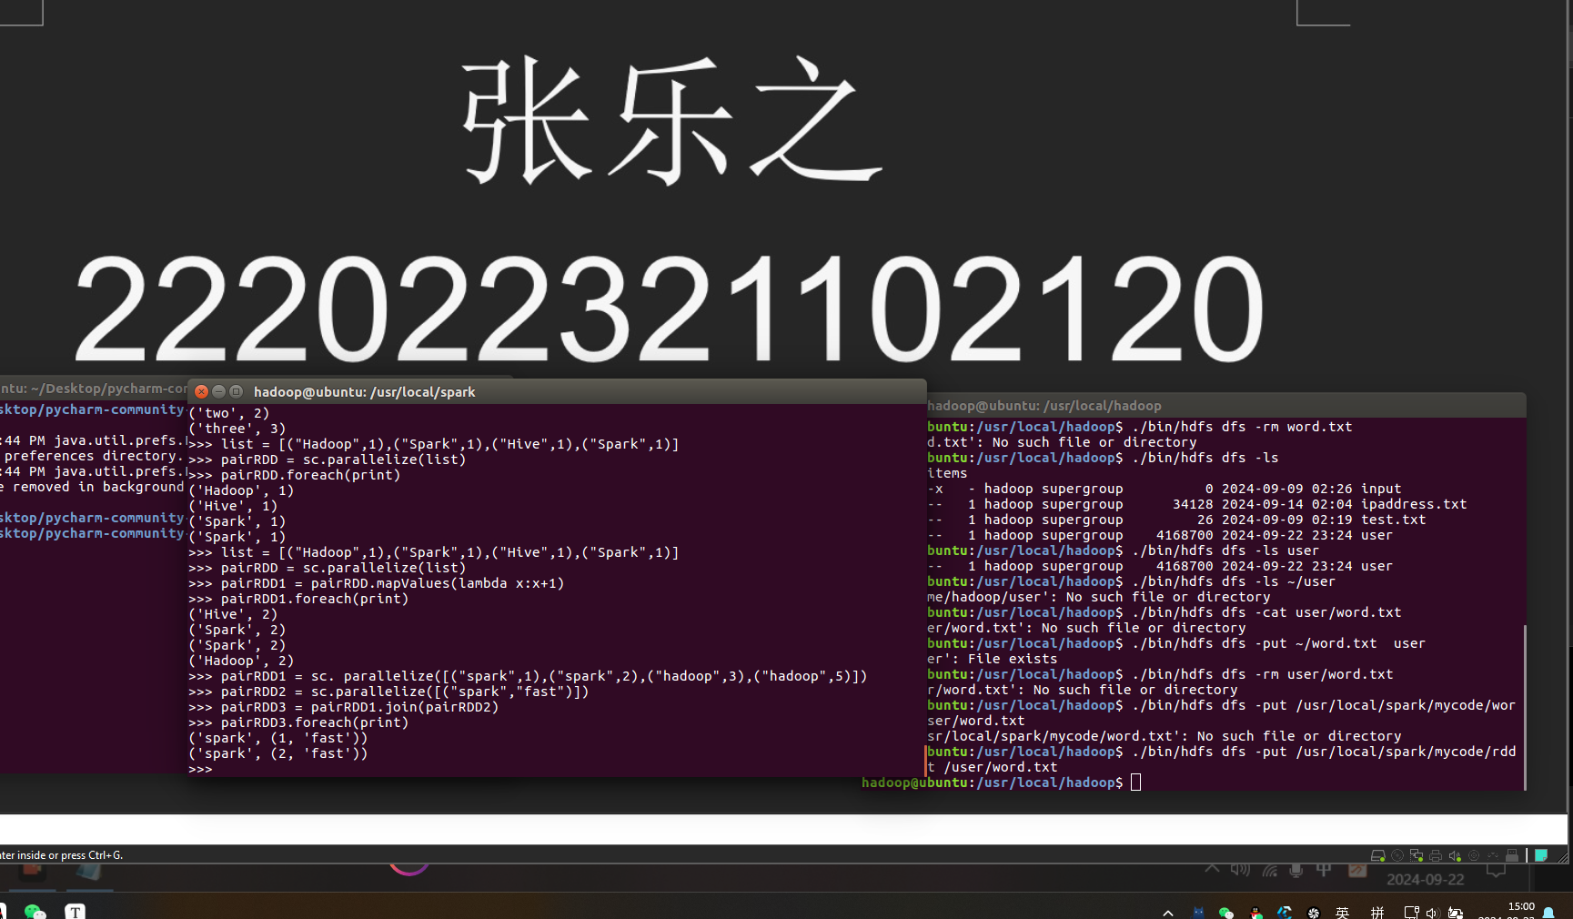

6、Combine

from pyspark import SparkConf, SparkContext

if __name__ == '__main__':

conf = SparkConf().setMaster("local[*]").setAppName("My App")

sc = SparkContext(conf = conf)

data = sc.parallelize([("company-1", 88), ("company-1", 96), ("company-1", 85), \

("company-2", 94), ("company-2", 86), ("company-2", 74), \

("company-3", 86), ("company-3", 88), ("company-3", 92)], 3)

res = data.combineByKey( \

lambda income: (income, 1), \

lambda acc, income: (acc[0] + income, acc[1] + 1), \

lambda acc1, acc2: (acc1[0] + acc2[0], acc1[1] + acc2[1])). \

map(lambda x: (x[0], x[1][0], x[1][0] / float(x[1][1])))

res.repartition(1) \

.saveAsTextFile("file:///usr/local/spark/mycode/rdd/combineresult")

sc.stop()

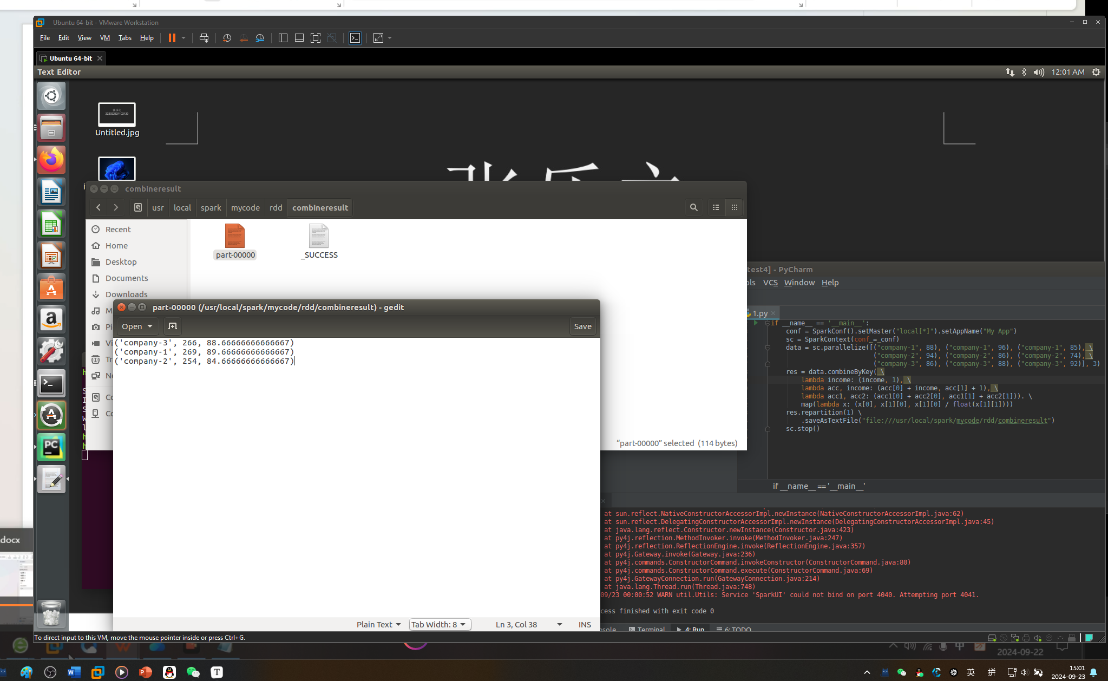

持久化：

>>> list = ["Hadoop","Spark","Hive"]

>>> rdd = sc.parallelize(list)

>>> print(rdd.count()) #行动操作，触发一次真正从头到尾的计算

3

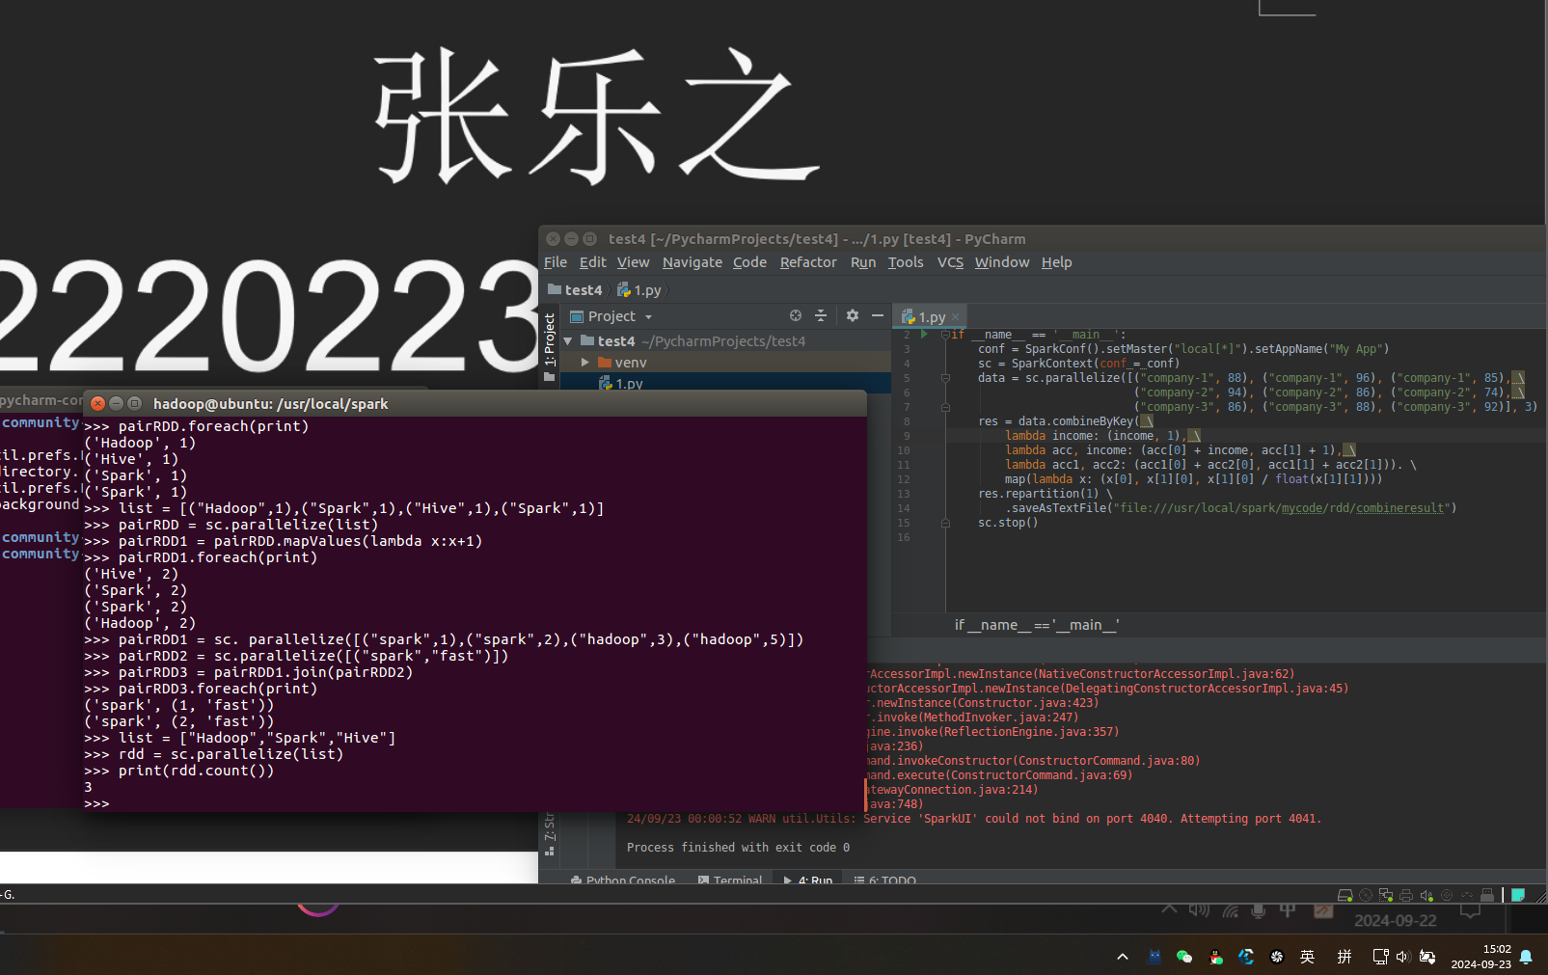

>>> print(','.join(rdd.collect())) #行动操作，触发一次真正从头到尾的计算

Hadoop,Spark,Hive

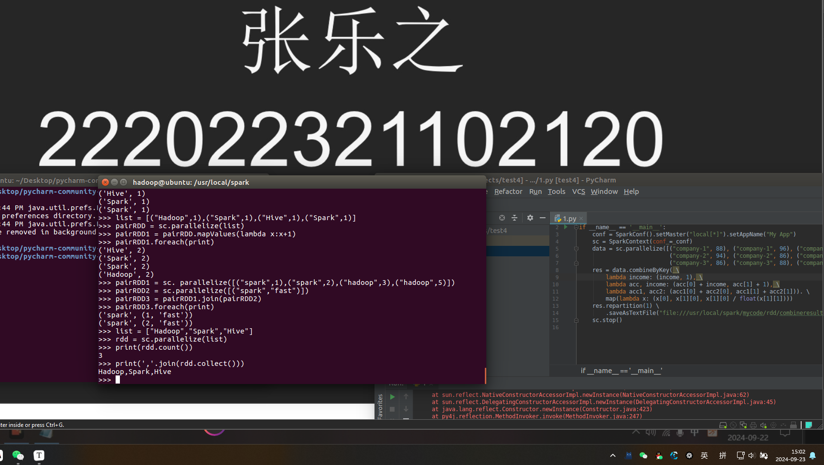

>>> list = ["Hadoop","Spark","Hive"]

>>> rdd = sc.parallelize(list)

>>> rdd.cache() #会调用persist(MEMORY_ONLY)，但是，语句执行到这里，并不会缓存rdd，因为这时rdd还没有被计算生成

>>> print(rdd.count()) #第一次行动操作，触发一次真正从头到尾的计算，这时上面的rdd.cache() #才会被执行，把这个rdd放到缓存中

3

>>> print(','.join(rdd.collect())) #第二次行动操作，不需要触发从头到尾的计算，只需要重复使

#用上面缓存中的rdd

Hadoop,Spark,Hive

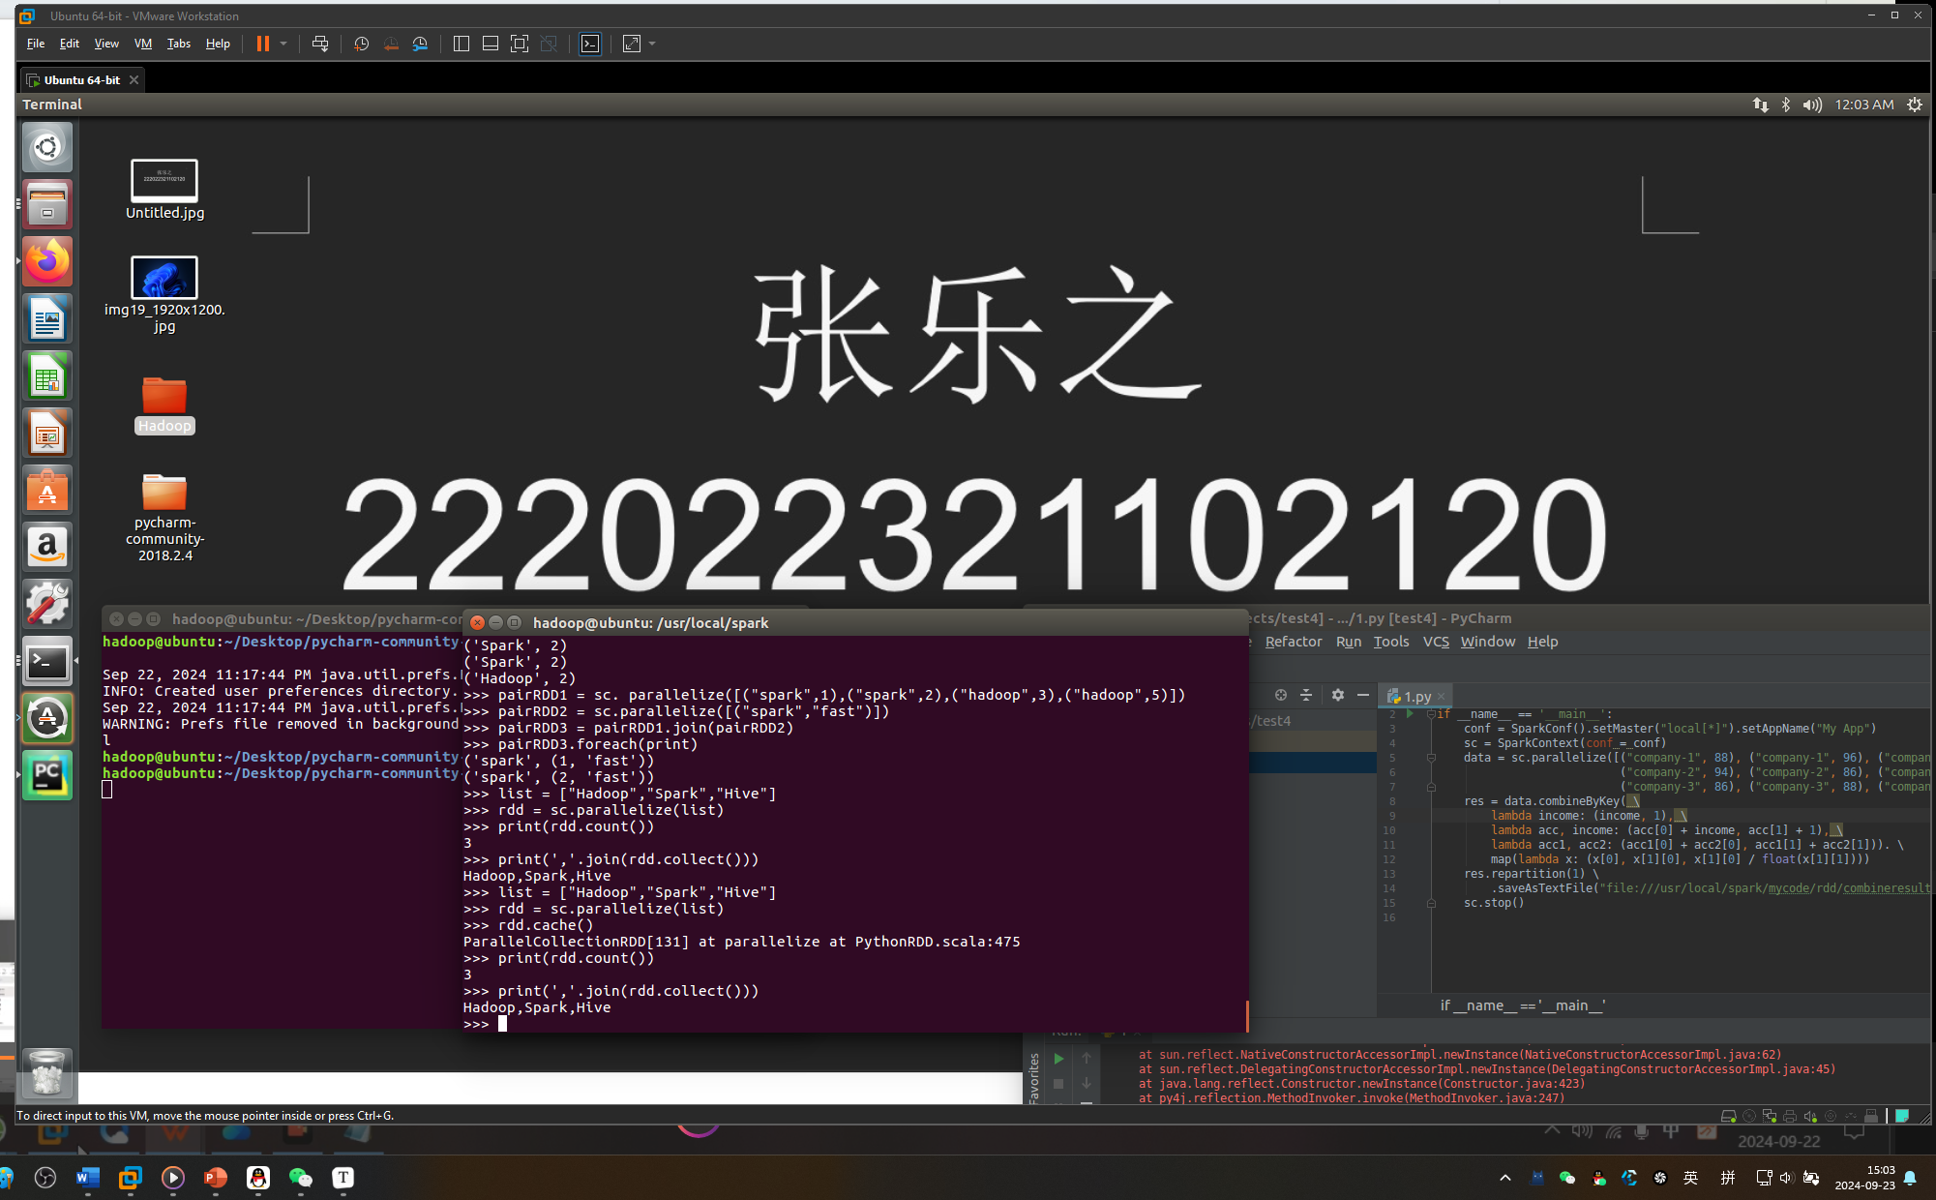

设置分区：

>>> list = [1,2,3,4,5]

>>> rdd = sc.parallelize(list,2) //设置两个分区

>>> data = sc.parallelize([1,2,3,4,5],2)

>>> len(data.glom().collect()) #显示data这个RDD的分区数量

2

>>> rdd = data.repartition(1) #对data这个RDD进行重新分区

>>> len(rdd.glom().collect()) #显示rdd这个RDD的分区数量

1

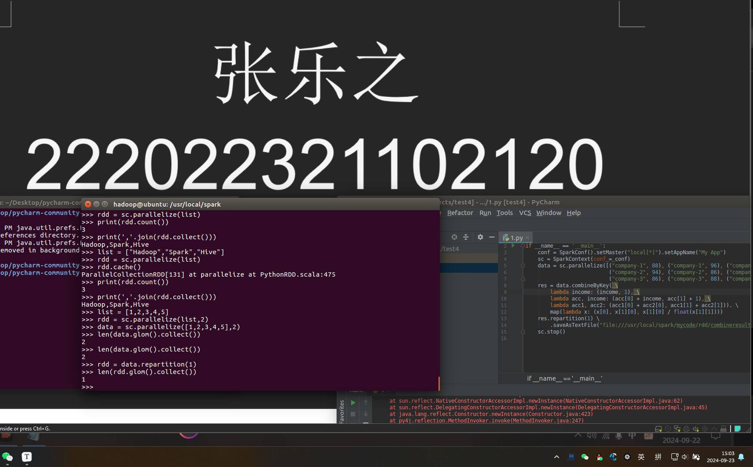

实验报告把结果截屏。

**2、**给定的实验数据pypark4-data1.txt，该数据集包含了某大学计算机系的成绩，数据格式如下所示：

|  |
| --- |
| Tom,DataBase,80  Tom,Algorithm,50  Tom,DataStructure,60  Jim,DataBase,90  Jim,Algorithm,60  Jim,DataStructure,80  …… |

请根据给定的实验数据，在pyspark中通过编程来计算以下内容：

（1）该系总共有多少学生；

（2）该系共开设了多少门课程；

（3）Tom同学的总成绩平均分是多少；

（4）求每名同学的选修的课程门数；

（5）该系DataBase课程共有多少人选修；

（6）各门课程的平均分是多少；

（7）使用累加器计算共有多少人选了DataBase这门课。

from pyspark import SparkContext

from pyspark.sql import SparkSession

# 创建 SparkSession

spark = SparkSession.builder.appName("UniversityScores").getOrCreate()

sc = spark.sparkContext

# 读取文件

data = sc.textFile("file:///usr/local/spark/mycode/rdd/pypark4-data1.txt")

# 解析每一行，数据格式: (name, course, score)

data_rdd = data.map(lambda line: line.split(','))

# 1. 统计总共有多少学生 (学生是唯一的名字)

students = data_rdd.map(lambda x: x[0]).distinct()

num_students = students.count()

print("总共有 {} 位学生".format(num_students))

# 2. 统计共开设了多少门课程 (唯一的课程名)

courses = data_rdd.map(lambda x: x[1]).distinct()

num_courses = courses.count()

print("共开设了 {} 门课程".format(num_courses))

# 3. 计算Tom同学的总成绩平均分

tom_scores = data_rdd.filter(lambda x: x[0] == "Tom").map(lambda x: int(x[2]))

tom_avg_score = tom_scores.mean()

print("Tom 的平均成绩是: {:.2f}".format(tom_avg_score))

# 4. 统计每名同学选修的课程门数

student_courses = data_rdd.map(lambda x: (x[0], x[1])).distinct().groupByKey().mapValues(len)

print("每名学生选修的课程数: {}".format(student_courses.collect()))

# 5. 统计 DataBase 课程的选修人数

database_students = data_rdd.filter(lambda x: x[1] == "DataBase").map(lambda x: x[0]).distinct()

num_database_students = database_students.count()

print("DataBase 课程共有 {} 人选修".format(num_database_students))

# 6. 计算各门课程的平均分

course_scores = data_rdd.map(lambda x: (x[1], int(x[2])))

course_avg_scores = course_scores.groupByKey().mapValues(lambda scores: sum(scores) / len(scores))

print("各门课程的平均分: {}".format(course_avg_scores.collect()))

# 7. 使用累加器计算选修 DataBase 课程的学生人数

acc = sc.accumulator(0)

def count_database_students(record):

if record[1] == "DataBase":

acc.add(1)

data_rdd.foreach(count_database_students)

print("使用累加器计算 DataBase 课程共有 {} 人选修".format(acc.value))

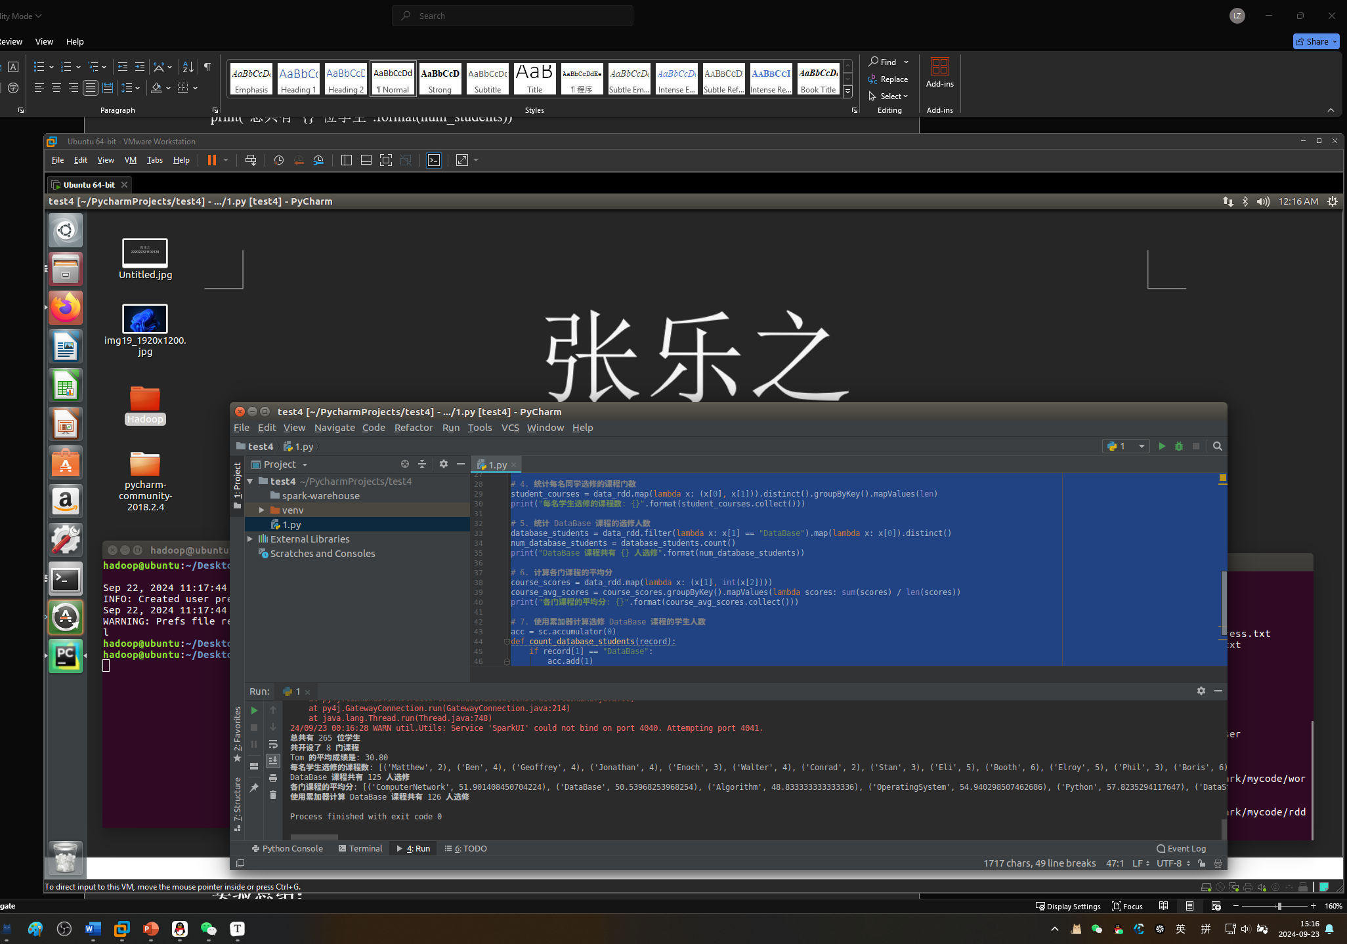

总共有 265 位学生

共开设了 8 门课程

Tom 的平均成绩是: 30.80

每名学生选修的课程数: [('Matthew', 2), ('Ben', 4), ('Geoffrey', 4), ('Jonathan', 4), ('Enoch', 3), ('Walter', 4), ('Conrad', 2), ('Stan', 3), ('Eli', 5), ('Booth', 6), ('Elroy', 5), ('Phil', 3), ('Boris', 6), ('Webb', 7), ('Jay', 6), ('Borg', 4), ('Bill', 2), ('Edward', 4), ('Rock', 6), ('Benjamin', 4), ('Baron', 6), ('Horace', 5), ('Bennett', 6), ('Hobart', 4), ('Lucien', 5), ('Kennedy', 4), ('Colin', 5), ('Bishop', 2), ('Bernard', 2), ('Ronald', 3), ('Cleveland', 4), ('Gordon', 4), ('Corey', 4), ('Aaron', 4), ('Donahue', 5), ('Clarence', 7), ('Ward', 4), ('Clark', 6), ('Mark', 7), ('Vic', 3), ('Greg', 4), ('Kerwin', 3), ('Elijah', 4), ('Perry', 5), ('Milo', 2), ('Joshua', 4), ('Bernie', 3), ('Devin', 4), ('Sidney', 5), ('Ron', 6), ('Rory', 4), ('Roderick', 4), ('Vincent', 5), ('Hiram', 6), ('Wright', 4), ('Alvin', 5), ('Antonio', 3), ('Brian', 6), ('Jeremy', 6), ('Lewis', 4), ('Leo', 5), ('Dean', 7), ('Adair', 3), ('Bart', 5), ('Hilary', 4), ('Leonard', 2), ('Brook', 4), ('Maxwell', 4), ('Merlin', 5), ('Winfred', 3), ('Virgil', 5), ('Les', 6), ('Roy', 6), ('Francis', 4), ('Jason', 4), ('Scott', 3), ('Sid', 3), ('Beck', 4), ('Nick', 5), ('Nicholas', 5), ('Pete', 3), ('Archer', 5), ('Andrew', 4), ('Hogan', 4), ('Matt', 4), ('Channing', 4), ('Upton', 5), ('Hayden', 3), ('Benson', 4), ('Colbert', 4), ('Ellis', 4), ('Harlan', 6), ('Colby', 4), ('Lou', 2), ('Don', 2), ('Ford', 3), ('Will', 3), ('Lennon', 4), ('Jim', 4), ('Adonis', 5), ('Blithe', 3), ('Dick', 3), ('Benedict', 6), ('Willie', 4), ('Alan', 5), ('Armstrong', 2), ('Elmer', 4), ('Alexander', 4), ('Bruno', 5), ('Tom', 5), ('Aldrich', 3), ('Elton', 5), ('Boyd', 3), ('Meredith', 4), ('Ken', 3), ('Marsh', 4), ('Christian', 2), ('Bertram', 3), ('Claude', 2), ('Uriah', 1), ('Bartholomew', 5), ('Miles', 6), ('Saxon', 7), ('Duncann', 5), ('Clement', 5), ('Cliff', 5), ('Wordsworth', 4), ('Michael', 5), ('Barry', 5), ('Leopold', 7), ('Tony', 3), ('Valentine', 5), ('Monroe', 3), ('Nigel', 3), ('Amos', 5), ('Duke', 4), ('Giles', 7), ('Victor', 2), ('Aries', 2), ('Armand', 3), ('Elliot', 3), ('Mike', 3), ('Glenn', 6), ('Bert', 3), ('Griffith', 4), ('Lester', 4), ('Charles', 3), ('Alston', 4), ('Angelo', 2), ('Christopher', 4), ('Robin', 4), ('Simon', 2), ('Randolph', 3), ('Herbert', 3), ('Solomon', 5), ('Jerry', 3), ('Harvey', 7), ('Winston', 4), ('Bevis', 4), ('Spencer', 5), ('Arlen', 4), ('Christ', 2), ('Louis', 6), ('Maurice', 2), ('George', 4), ('Clyde', 7), ('Martin', 3), ('Marshall', 4), ('Mick', 4), ('Bruce', 3), ('Alger', 5), ('Marico', 6), ('Rod', 4), ('Donald', 4), ('Merle', 3), ('Archibald', 5), ('Derrick', 6), ('Ernest', 5), ('Sandy', 1), ('Woodrow', 3), ('Kent', 4), ('Jeff', 4), ('Allen', 4), ('Chapman', 4), ('Tracy', 3), ('Kevin', 4), ('Joseph', 3), ('Bing', 6), ('Elvis', 2), ('Abel', 4), ('Chad', 6), ('William', 6), ('Herman', 3), ('Clare', 4), ('Dominic', 4), ('Len', 5), ('Boyce', 2), ('Blair', 4), ('Noah', 4), ('Eugene', 1), ('Luthers', 5), ('Dennis', 4), ('Berg', 4), ('John', 6), ('Alva', 5), ('Alfred', 2), ('Brady', 5), ('Sebastian', 6), ('Broderick', 3), ('Egbert', 4), ('Henry', 2), ('Jo', 5), ('Marlon', 4), ('Samuel', 4), ('Drew', 5), ('Nelson', 5), ('Jerome', 3), ('Sean', 6), ('Raymondt', 6), ('Gilbert', 3), ('Bradley', 2), ('Harold', 4), ('Todd', 3), ('Jonas', 4), ('Emmanuel', 3), ('Basil', 4), ('Brandon', 5), ('Peter', 4), ('Bowen', 5), ('Andy', 3), ('Montague', 3), ('Max', 3), ('Harry', 4), ('Barton', 1), ('Kim', 4), ('Antony', 5), ('Levi', 2), ('Kerr', 4), ('Philip', 2), ('Payne', 6), ('Rodney', 3), ('Jeffrey', 4), ('Adam', 3), ('Adolph', 4), ('Frank', 3), ('Albert', 3), ('Abbott', 3), ('Truman', 3), ('Verne', 3), ('Webster', 2), ('Ivan', 4), ('Alvis', 6), ('Eric', 4), ('Abraham', 3), ('Marvin', 3), ('Gerald', 4), ('Evan', 3), ('Newman', 2), ('Kenneth', 3), ('Bob', 3), ('Lionel', 4), ('Dempsey', 4), ('Chester', 6), ('Jesse', 7), ('Blake', 4)]

DataBase 课程共有 125 人选修

各门课程的平均分: [('ComputerNetwork', 51.901408450704224), ('DataBase', 50.53968253968254), ('Algorithm', 48.833333333333336), ('OperatingSystem', 54.940298507462686), ('Python', 57.8235294117647), ('DataStructure', 47.57251908396947), ('CLanguage', 50.609375), ('Software', 50.90909090909091)]

使用累加器计算 DataBase 课程共有 126 人选修

**实验总结：**

在本次实验中，我主要学习了 **PySpark** 技术来处理并分析数据。我深刻认识到了分布式计算的原理和操作方法。通过将数据加载为 RDD，利用分布式计算模型高效地进行数据过滤、分组和聚合操作。实验中涉及了学生人数、课程数量、个人成绩平均值、选修人数等多种统计需求，充分利用了 PySpark 的 map(), filter(), groupByKey() 等核心函数。同时，使用了 PySpark 的 **累加器** 来跟踪特定课程的选修人数，展示了在分布式计算中的计数功能。